What is sensory processing?

The term ‘sensory processing’ describes how we understand information from the world around us – through our senses – sight, hearing, touch, taste and smell.

Some children may show a heightened response to some sensations. To support sensory needs, providing children with sensory activities can help them to interact more successfully with their environments. Especially during a difficult time such as this!

Parents can boost emotional, intellectual and social development of their children and help them improve self-esteem by assisting them with sensory integration exercises/activities.

(A great many children under the age of five, with no sensory processing issues, will find certain parts of their daily routine difficult. These often include bath time, hair brushing, visiting the supermarket and loud or unpredictable noises.)

I know some foods are in very short supply at the moment, but if like me you have decided to clean out your cupboards during this unusual time of being in the house more and you have found some out of date things – just like I have – you might want to have a go at this.

Playdough can be a great sensory activity; it can be used to help children who struggle with sensory processing disorder. Sensory seeking children can squish, squash, pound and gloop the playdough to give themselves lovely tactile feedback.

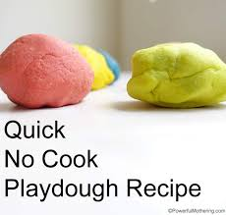

Best Ever No-Cook Play Dough Recipe

- 2 cups plain flour
- 2 tablespoons vegetable oil (baby oil and coconut oil work too)
- 1/2 cup salt
- 2 tablespoons cream of tartar
- 1 to 1.5 cups boiling water (adding in increments until it feels just right)
- food colouring (optional)
- Spices, glitter, etc (optional)

Method
- Mix the flour, salt, cream of tartar and oil in a large mixing bowl
- Add food colouring TO the boiling water then into the dry ingredients
- Stir continuously until it becomes a sticky, combined dough
- Allow it to cool down then take it out of the bowl and knead it vigorously for a couple of minutes until all of the stickiness has gone. * This is the most important part of the process, so keep at it until it’s the perfect consistency! *
- If it remains a little sticky, then add a touch more flour until just right
Helping to make the dough is a great sensory activity before children even start to play with it!
Sensory Spice Painting
Spice Painting is a fun way to make some creative art – with a sensory twist!
To make the spice paint, pour washable white paint into four small bowls, then added paprika, turmeric, cardamom and cinnamon. Depending on what you have in the cupboard, especially all those out of date spices!
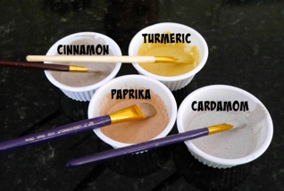
Any ground spice might be worth trying!

No paint brush, no problem. Please see below!

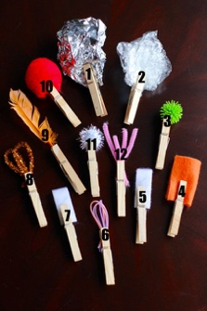
DIY paint brushes

Use a peg to pinch your new paintbrush heads. Some of them may need a piece of tape wrapped around to ensure the end stays firmly grasped in the pen and now you’re ready to paint.

Brush ideas:

- Tin foil
- Cling film
- Felt
- Velcro (soft side)
- Velcro (scratchy side)
- Pipe cleaner
- Feather
- Pom poms
- Pipe cleaner (fluffy)
- Bubble wrap
- Leaves
- Ribbon
- Kitchen sponge
- Makeup sponge
- Loofah (mesh, sponge)
- Cardboard
- Cotton balls
- Marshmallows
- Balloons
- Pasta
Playing with bubbles in the sink

(add a hand whisk for extra points!), You can also do this in the bath, back yard or garden. Rather than fill the bath, sit your child in the bath with a plastic bowl and some kitchen utensils, bubbly water and let them go at it. If you need to work, grab your laptop and make yourself comfy in the bathroom – not ideal but at least you can get some work done!

Ice Treasure

How to make it. Get a plastic tupperware style box or similar and search the house for 'treasure' plastic animals, beads, buttons, coins and other plastic toys. Put a few bits of treasure in the box and fill with water about 1/3 of the box.
Pop into the freezer.
When that layer has frozen, add another layer of treasure and freeze again.
Add a final layer and freeze.
Then when you get it out give your child the block and tell them to get the treasure. This usually involves several experiments of the best way to get the treasure out.

My year 1 children loved this as a science experiment, I know this will be an instant hit.

Toy Olympics

Many thanks to Laura Parton at Inclusion Solutions for this fab idea! It will require some planning but can be done with things you already have.

Explain to your child/children that you need help with a special mission! All of the toys are having a competition. They want to know which is the best toy in each house. Can you help?

This will be decided by lots of different competitions:
- Who is the heaviest?
- Who is the tallest?
- Who can roll the furthest?
- Who is easiest to make a picture of?
- Who has the most colours?
The toys will get points for each competition.

First, please can you pick your favourite 10 toys.

Here are the toys that are competing at my house:
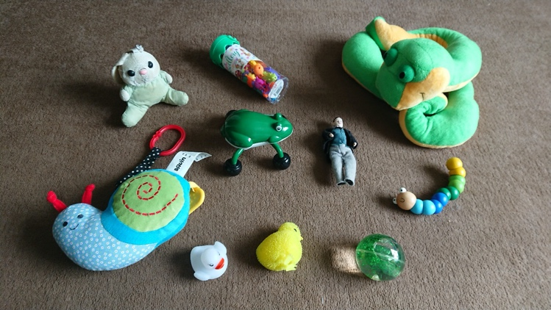

Now we need a scoreboard!
- Heaviest
- Tallest
- Rolling
- Picture
- Colours
- Toys
- Total Points
Please can you put these into a grid.



