Our Worries

Ruby’s Worry by Tom Percival
Watch Ruby’s Worry on YouTube https://www.youtube.com/watch?v=LWS0Q5oCUNE

Think about these questions or talk about them with someone.

-Can you think of a time when you have been worried?

…………………………………………………………………………
-How did Ruby find help for her worries?

…………………………………………………………………………
-Do you think it was a good idea for Ruby to pretend she couldn’t see her worry?

…………………………………………………………………………
-Were Ruby’s worries gone forever?

…………………………………………………………………………

Challenge

Create your own worry cloud.
Sometimes worries can feel really big, until you let them out and speak to others about them.
I would like you to create your own worry cloud, which you can share on SeeSaw with your teacher, or with another person you trust.

A Moment to Remember!

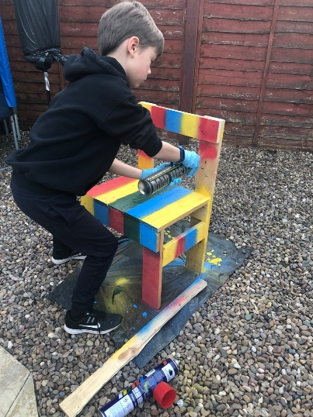
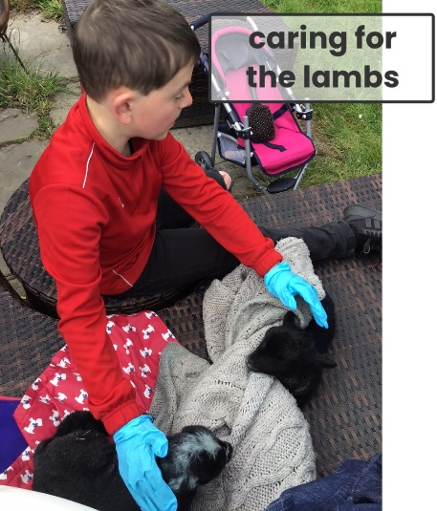


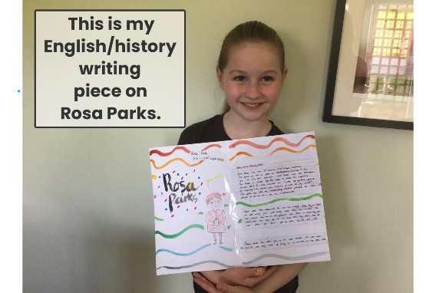


Challenge

Your challenge is to create poster to tell me about your proudest, most exciting or happiest moment you’ve had whilst you have been at home.

This could include-

- A short recount
-Drawings or photographs
- Emotion words to describe how you felt
A Positive Day!

We know that at the minute it’s completely okay not to be okay all of the time. Things are different, and we can’t do everything we want to do.
We want to work together to find ways to help us feel a little better sometimes.

Challenge

Create a poster or presentation to be shown which shows how you try and stay positive and encourages others to do the same!

Think about what you do to stay in a positive mindset, activities you take part in or techniques which make you feel better, calm you down when you feel a little anxious or put a smile on your face when you feel sad.

Below are also links to a calming videos on YouTube from our PSHE lessons 1decision- I find these really helpful to calm myself and stay positive!
https://www.youtube.com/watch?v=KdIGew0vKlI Managing Worry
https://www.youtube.com/watch?v=-pye091kE9k&t=8s Flower Breath
https://www.youtube.com/watch?v=sNebFdm6LU4 Magic Cloud

A Jar of Happiness, Hopes and Dreams
Sometimes we all need a pick me up. A happiness jar can be just that!

Your challenge
- First, you need to get yourself a jar- this could be from around your home or ask an adult to get one from the shop.
- Then decorate your jar! Add the label ‘A Jar of Happiness’.
- Now, every time you do something you’ve really enjoyed, something which makes you happy, something you are proud of, add it to the jar!
- When you are feeling a little down, you can take something out of the jar, remember it and maybe even relive it! Bake that cake, go on that hike, create a beautiful artwork!
- Lastly, when this is all over, don’t forget to keep using the jar. All of these skills and happy memories can stay with you. You can still do all of these things even when we return to school.
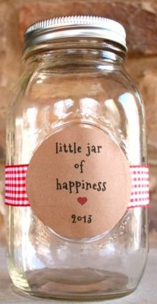
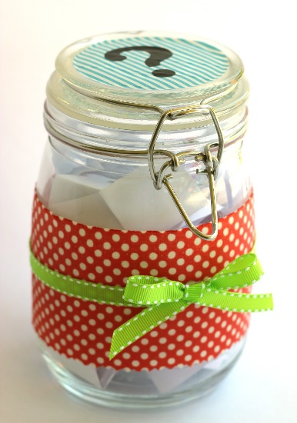
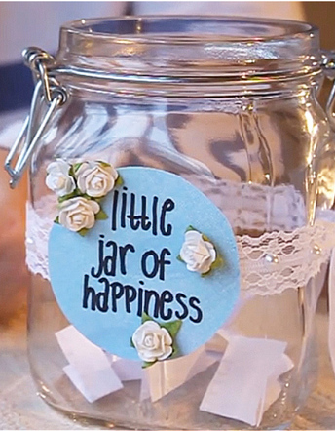

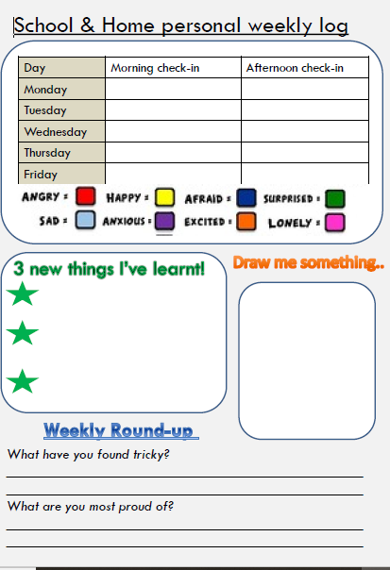

0

