
Water Primary School
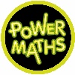
Calculation Policy 2022/2023
Linked to Power Maths

The following pages show the Power Maths progression in calculation (addition, subtraction, multiplication and division) and how this works in line with the National Curriculum. The consistent use of the CPA (concrete, pictorial, abstract) approach across Power Maths helps children develop mastery across all the operations in an efficient and reliable way. This policy shows how these methods develop children’s confidence in their understanding of both written and mental methods.

Contents
Upper Key Stage Two – pages 60-85
- Overview- page 60
- Year 5- page 61
  - Addition- pages 62-63
  - Subtraction- pages 64-65
  - Multiplication- pages 66-69
  - Division- pages 70-74
- Year 6- page 75
  - Addition- pages 76-77
  - Subtraction- page 78
  - Multiplication- pages 79-81
  - Division- pages 82-85

Lower Key Stage Two – pages 25-59
- Overview- page 25
- Year 3- page 26
  - Addition- pages 27-33
  - Subtraction- pages 34-38
  - Multiplication- pages 39-43
  - Division- pages 44-46
- Year 4- page 47
  - Addition- pages 48-50
  - Subtraction- pages 51-53
  - Multiplication- pages 54-56
  - Division- pages 57-59

Key Stage One – pages 2-24
- Overview- page 2
- Year 1- page 3
  - Addition- pages 4-6
  - Subtraction- pages 7-9
  - Multiplication- page 10
  - Division- page 11
- Year 2- page 12
  - Addition- pages 13-17
  - Subtraction- pages 18-20
  - Multiplication- pages 21-22
  - Division- pages 23-24
KEY STAGE 1
Children develop the core ideas that underpin all calculation. They begin by connecting calculation with counting on and counting back, but they should learn that understanding wholes and parts will enable them to calculate efficiently and accurately, and with greater flexibility. They learn how to use an understanding of 10s and 1s to develop their calculation strategies, especially in addition and subtraction.
Key language: whole, part, ones, ten, tens, number bond, add, addition, plus, total, altogether, subtract, subtraction, find the difference, take away, minus, less, more, group, share, equal, equals, is equal to, groups, equal groups, times, multiply, multiplied by, divide, share, shared equally, times-table
Addition and subtraction: Children first learn to connect addition and subtraction with counting, but they soon develop two very important skills: an understanding of parts and wholes, and an understanding of unitising 10s, to develop efficient and effective calculation strategies based on known number bonds and an increasing awareness of place value. Addition and subtraction are taught in a way that is interlinked to highlight the link between the two operations.  A key idea is that children will select methods and approaches based on their number sense. For example, in Year 1, when faced with 15 − 3 and 15 − 13, they will adapt their ways of approaching the calculation appropriately. The teaching should always emphasise the importance of mathematical thinking to ensure accuracy and flexibility of approach, and the importance of using known number facts to harness their recall of bonds within 20 to support both addition and subtraction methods.  In Year 2, they will start to see calculations presented in a column format, although this is not expected to be formalised until KS2. We show the column method in Year 2 as an option; teachers may not wish to include it until Year 3. |  | Multiplication and division: Children develop an awareness of equal groups and link this with counting in equal steps, starting with 2s, 5s and 10s. In Year 2, they learn to connect the language of equal groups with the mathematical symbols for multiplication and division.  They learn how multiplication and division can be related to repeated addition and repeated subtraction to find the answer to the calculation.  In this key stage, it is vital that children explore and experience a variety of strong images and manipulative representations of equal groups, including concrete experiences as well as abstract calculations.  Children begin to recall some key multiplication facts, including doubles, and an understanding of the 2, 5 and 10 times-tables and how they are related to counting. |  | Fractions: In Year 1, children encounter halves and quarters, and link this with their understanding of sharing. They experience key spatial representations of these fractions, and learn to recognise examples and non-examples, based on their awareness of equal parts of a whole.  In Year 2, they develop an awareness of unit fractions and experience non-unit fractions, and they learn to write them and read them in the common format of numerator and denominator.
Year 1
 | Concrete |  | Pictorial |  | Abstract
Year 1
Addition
 | Counting and adding more  Children add one more person or object to a group to find one more. |  | Counting and adding more  Children add one more cube or counter to a group to represent one more.  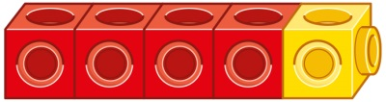  One more than 4 is 5. |  | Counting and adding more  Use a number line to understand how to link counting on with finding one more.  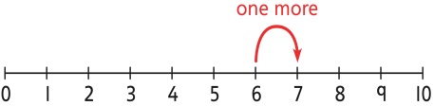  One more than 6 is 7.  7 is one more than 6.  Learn to link counting on with adding more than one.  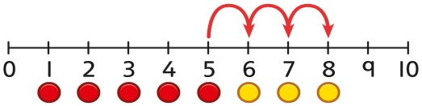  5 + 3 = 8
 | Understanding part-part-whole relationship  Sort people and objects into parts and understand the relationship with the whole.  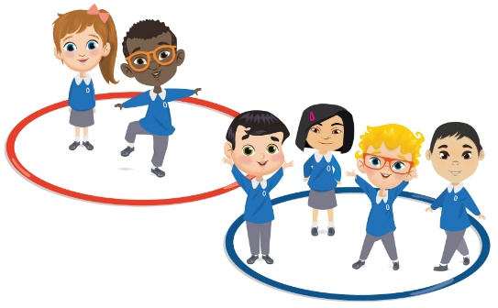  The parts are 2 and 4. The whole is 6. |  | Understanding part-part-whole relationship  Children draw to represent the parts and understand the relationship with the whole.  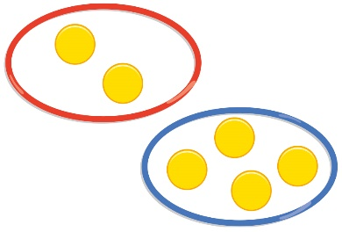  The parts are 1 and 5. The whole is 6. |  | Understanding part-part-whole relationship  Use a part-whole model to represent the numbers.  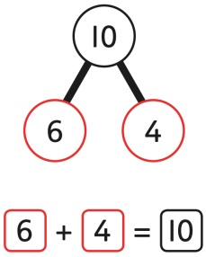  6 + 4 = 10
 | Knowing and finding number bonds within 10  Break apart a group and put back together to find and form number bonds.  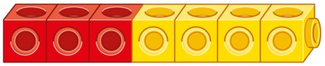  3 + 4 = 7  6 = 2 + 4 |  | Knowing and finding number bonds within 10  Use five and ten frames to represent key number bonds.  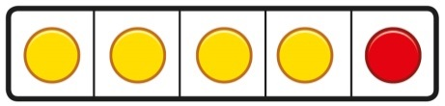  5 = 4 + 1  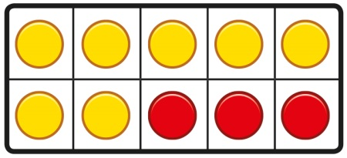  10 = 7 + 3 |  | Knowing and finding number bonds within 10  Use a part-whole model alongside other representations to find number bonds. Make sure to include examples where one of the parts is zero.  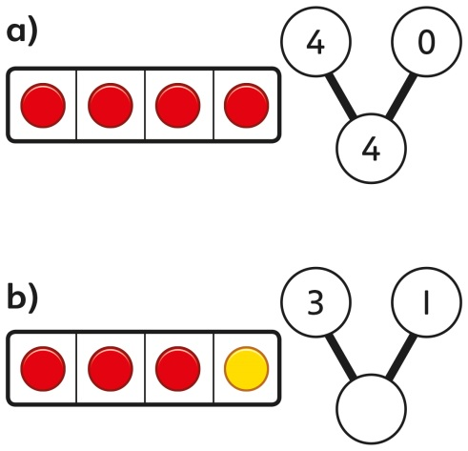  4 + 0 = 4  3 + 1 = 4
 | Understanding teen numbers as a complete 10 and some more  Complete a group of 10 objects and count more.  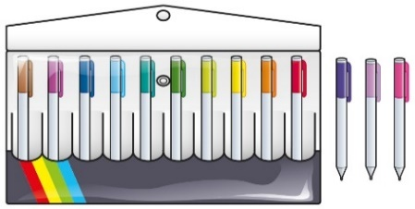  13 is 10 and 3 more. |  | Understanding teen numbers as a complete 10 and some more  Use a ten frame to support understanding of a complete 10 for teen numbers.  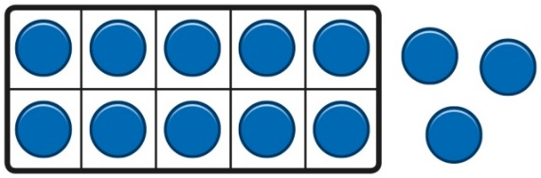  13 is 10 and 3 more. |  | Understanding teen numbers as a complete 10 and some more.  1 ten and 3 ones equal 13.  10 + 3 = 13
 | Adding by counting on  Children use knowledge of counting to 20 to find a total by counting on using people or objects.  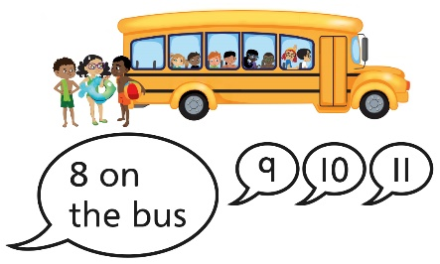 |  | Adding by counting on  Children use counters to support and represent their counting on strategy.  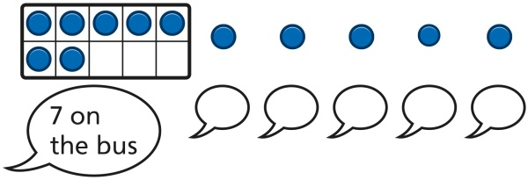 |  | Adding by counting on  Children use number lines or number tracks to support their counting on strategy.  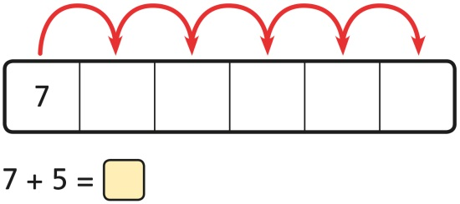
 | Adding the 1s  Children use bead strings to recognise how to add the 1s to find the total efficiently.  2 + 3 = 5  12 + 3 = 15 |  | Adding the 1s  Children represent calculations using ten frames to add a teen and 1s.  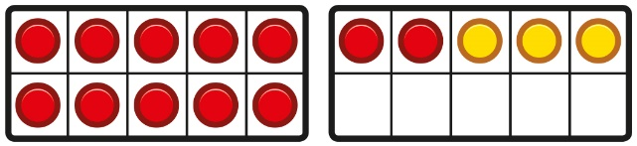  2 + 3 = 5  12 + 3 = 15 |  | Adding the 1s  Children recognise that a teen is made from a 10 and some 1s and use their knowledge of addition within 10 to work efficiently.  3 + 5 = 8  So, 13 + 5 = 18
 | Bridging the 10 using number bonds  Children use a bead string to complete a 10 and understand how this relates to the addition.  7 add 3 makes 10.  So, 7 add 5 is 10 and 2 more. |  | Bridging the 10 using number bonds  Children use counters to complete a ten frame and understand how they can add using knowledge of number bonds to 10.  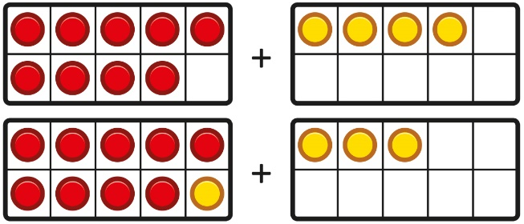  . |  | Bridging the 10 using number bonds  Use a part-whole model and a number line to support the calculation.  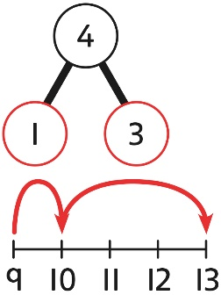  9 + 4 = 13
Year 1
Subtraction
 | Counting back and taking away  Children arrange objects and remove to find how many are left.  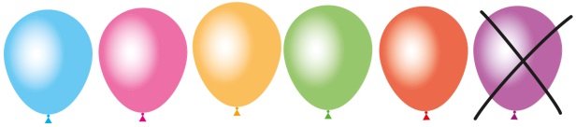  1 less than 6 is 5.  6 subtract 1 is 5. |  | Counting back and taking away  Children draw and cross out or use counters to represent objects from a problem.  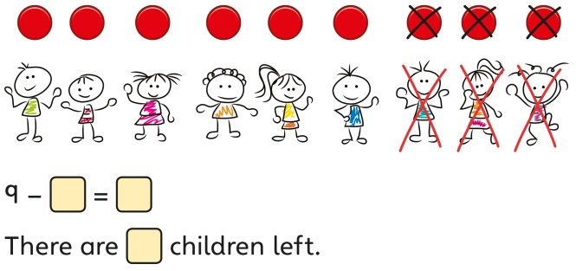 |  | Counting back and taking away  Children count back to take away and use a number line or number track to support the method.  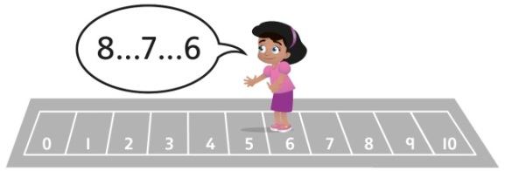  9 − 3 = 6
 | Finding a missing part, given a whole and a part  Children separate a whole into parts and understand how one part can be found by subtraction.  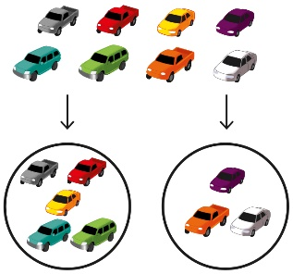  8 − 5 = ? |  | Finding a missing part, given a whole and a part  Children represent a whole and a part and understand how to find the missing part by subtraction.  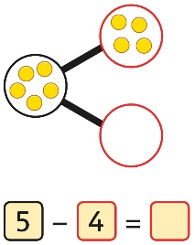 |  | Finding a missing part, given a whole and a part  Children use a part-whole model to support the subtraction to find a missing part.  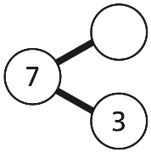  7 − 3 = ?  Children develop an understanding of the relationship between addition and subtraction facts in a part-whole model.  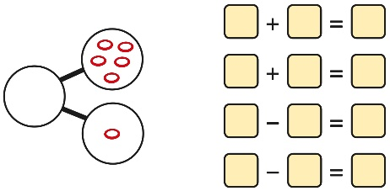
 | Finding the difference  Arrange two groups so that the difference between the groups can be worked out.  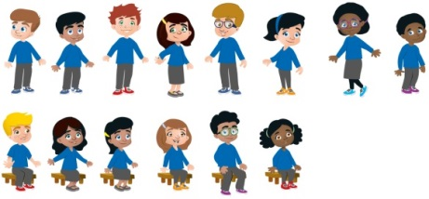  8 is 2 more than 6.  6 is 2 less than 8.  The difference between 8 and 6 is 2. |  | Finding the difference  Represent objects using sketches or counters to support finding the difference.  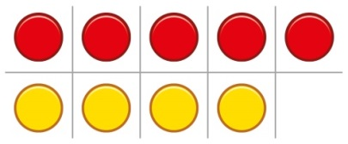  5 − 4 = 1  The difference between 5 and 4 is 1. |  | Finding the difference  Children understand ‘find the difference’ as subtraction.  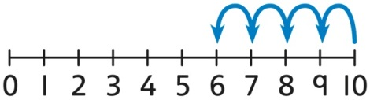  10 − 4 = 6  The difference between 10 and 6 is 4.
 | Subtraction within 20  Understand when and how to subtract 1s efficiently.  Use a bead string to subtract 1s efficiently.  5 − 3 = 2  15 − 3 = 12 |  | Subtraction within 20  Understand when and how to subtract 1s efficiently.  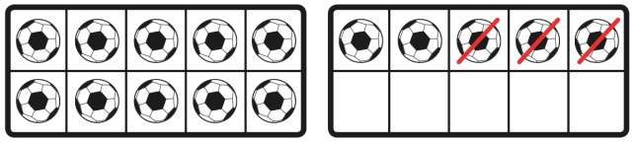  5 − 3 = 2  15 − 3 = 12 |  | Subtraction within 20  Understand how to use knowledge of bonds within 10 to subtract efficiently.  5 − 3 = 2  15 − 3 = 12
 | Subtracting 10s and 1s  For example: 18 − 12  Subtract 12 by first subtracting the 10, then the remaining 2.  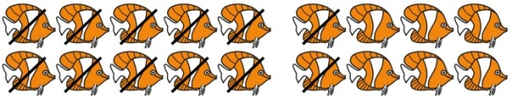  First subtract the 10, then take away 2. |  | Subtracting 10s and 1s  For example: 18 − 12  Use ten frames to represent the efficient method of subtracting 12.  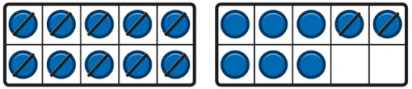  First subtract the 10, then subtract 2. |  | Subtracting 10s and 1s  Use a part-whole model to support the calculation.  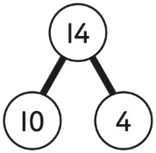  19 − 14  19 − 10 = 9  9 − 4 = 5  So, 19 − 14 = 5
 | Subtraction bridging 10 using number bonds  For example: 12 − 7  Arrange objects into a 10 and some 1s, then decide on how to split the 7 into parts.  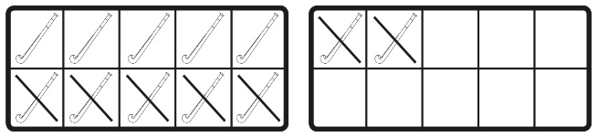  7 is 2 and 5, so I take away the 2 and  then the 5. |  | Subtraction bridging 10 using number bonds  Represent the use of bonds using ten frames.  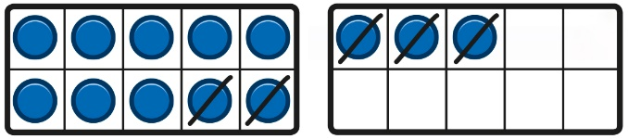  For 13 – 5, I take away 3 to make 10, then take away 2 to make 8. |  | Subtraction bridging 10 using number bonds  Use a number line and a part-whole model to support the method.  13 − 5  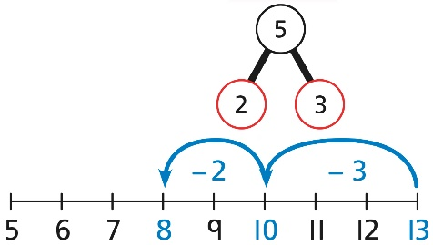
Year 1
Multiplication
 | Recognising and making equal groups  Children arrange objects in equal and unequal groups and understand how to recognise whether they are equal.  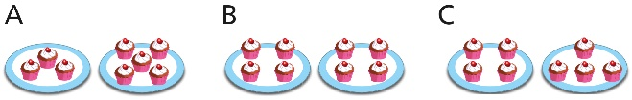 |  | Recognising and making equal groups  Children draw and represent equal and unequal groups.  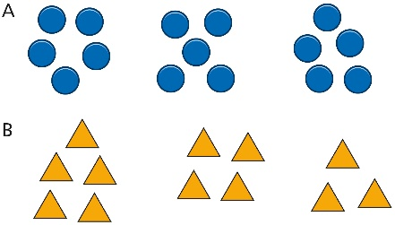 |  | Describe equal groups using words  Three equal groups of 4.  Four equal groups of 3.
 | Finding the total of equal groups by counting in 2s, 5s and 10s  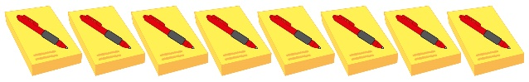  There are 5 pens in each pack …  5…10…15…20…25…30…35…40… |  | Finding the total of equal groups by counting in 2s, 5s and 10s  100 squares and ten frames support counting in 2s, 5s and 10s.  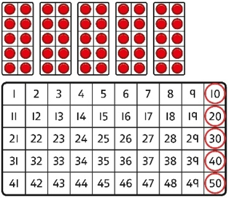 |  | Finding the total of equal groups by counting in 2s, 5s and 10s  Use a number line to support repeated addition through counting in 2s, 5s and 10s.  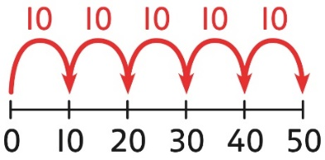
Year 1
Division
 | Grouping  Learn to make equal groups from a whole and find how many equal groups of a certain size can be made.  Sort a whole set people and objects into equal groups.  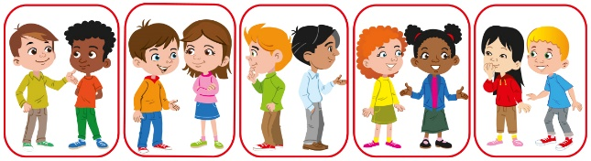  There are 10 children altogether.  There are 2 in each group.  There are 5 groups. |  | Grouping  Represent a whole and work out how many equal groups.    There are 10 in total.  There are 5 in each group.  There are 2 groups. |  | Grouping  Children may relate this to counting back in steps of 2, 5 or 10.  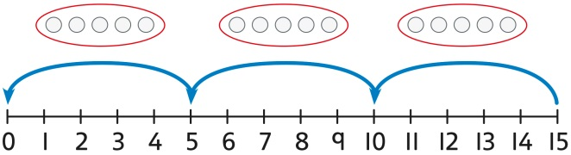
 | Sharing  Share a set of objects into equal parts and work out how many are in each part.  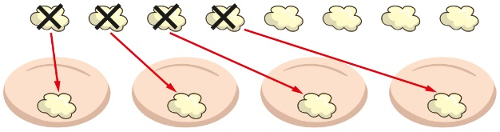 |  | Sharing  Sketch or draw to represent sharing into equal parts. This may be related to fractions.  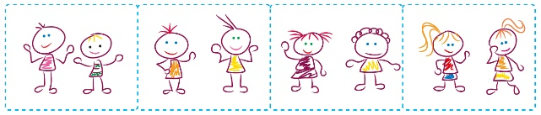 |  | Sharing  10 shared into 2 equal groups gives 5 in each group.

Year 2
 | Concrete | Pictorial | Abstract
Year 2
Addition
Understanding 10s and 1s | Group objects into 10s and 1s.  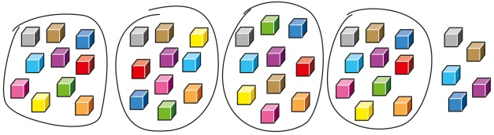  Bundle straws to understand unitising of 10s.  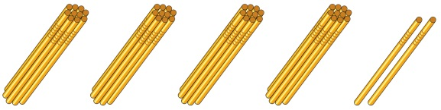 | Understand 10s and 1s equipment, and link with visual representations on ten frames.  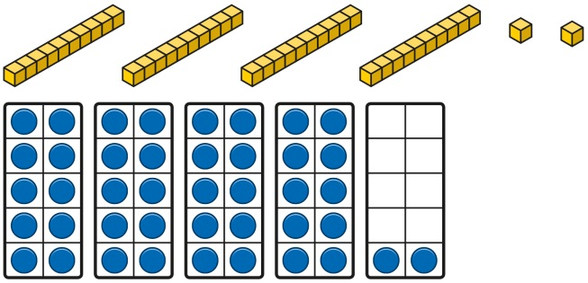 | Represent numbers on a place value grid, using equipment or numerals.  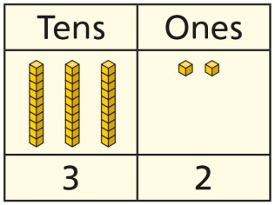  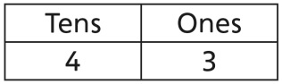
Adding 10s | Use known bonds and unitising to add 10s.  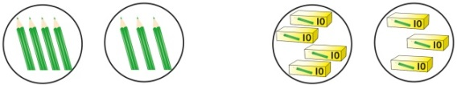  I know that 4 + 3 = 7.  So, I know that 4 tens add 3 tens is 7 tens. | Use known bonds and unitising to add 10s.  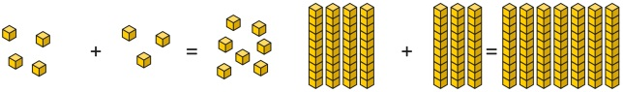  I know that 4 + 3 = 7.  So, I know that 4 tens add 3 tens is 7 tens. | Use known bonds and unitising to add 10s.  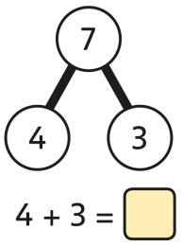  4 + 3 = 7  4 tens + 3 tens = 7 tens  40 + 30 = 70
Adding a  1-digit number to a 2-digit number not bridging a 10 | Add the 1s to find the total. Use known bonds within 10.  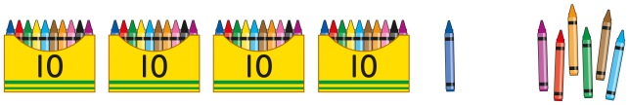  41 is 4 tens and 1 one.  41 add 6 ones is 4 tens and 7 ones.  This can also be done in a place value grid.  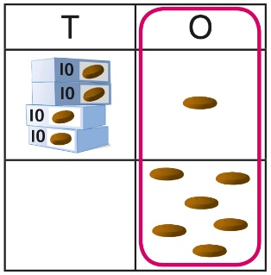 | Add the 1s.  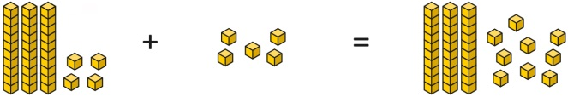  34 is 3 tens and 4 ones.  4 ones and 5 ones are 9 ones.  The total is 3 tens and 9 ones.  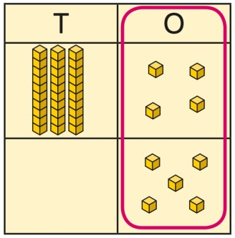 | Add the 1s.  Understand the link between counting on and using known number facts. Children should be encouraged to use known number bonds to improve efficiency and accuracy.  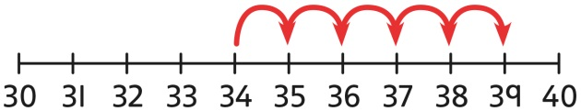  This can be represented horizontally or vertically.  34 + 5 = 39  or  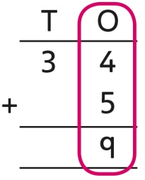
Adding a  1-digit number to a 2-digit number bridging 10 | Complete a 10 using number bonds.  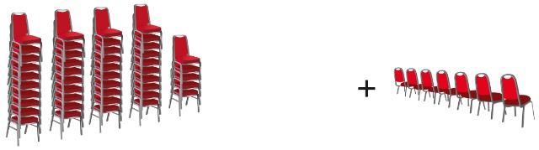  There are 4 tens and 5 ones.  I need to add 7. I will use 5 to complete a 10, then add 2 more. | Complete a 10 using number bonds.  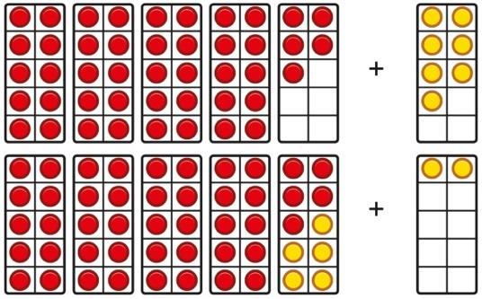 | Complete a 10 using number bonds.  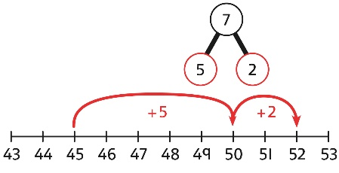  7 = 5 + 2  45 + 5 + 2 = 52
Adding a  1-digit number to a 2-digit number using exchange | Exchange 10 ones for 1 ten.  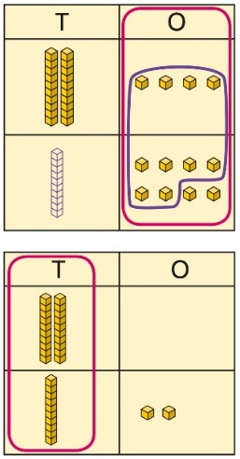 | Exchange 10 ones for 1 ten.  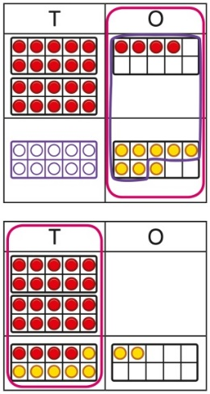 | Exchange 10 ones for 1 ten.  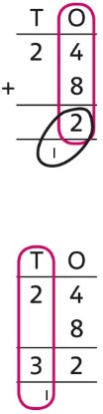
Adding a multiple of 10 to a 2-digit number | Add the 10s and then recombine.  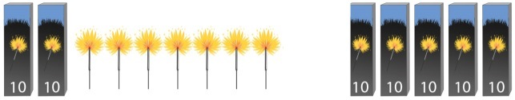  27 is 2 tens and 7 ones.  50 is 5 tens.  There are 7 tens in total and 7 ones.  So, 27 + 50 is 7 tens and 7 ones. | Add the 10s and then recombine.  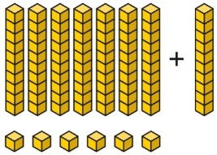  66 is 6 tens and 6 ones.  66 + 10 = 76  A 100 square can support this understanding.  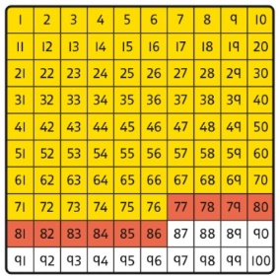 | Add the 10s and then recombine.  37 + 20 = ?  30 + 20 = 50  50 + 7 = 57  37 + 20 = 57
Adding a multiple of 10 to a 2-digit number using columns | Add the 10s using a place value grid to support.  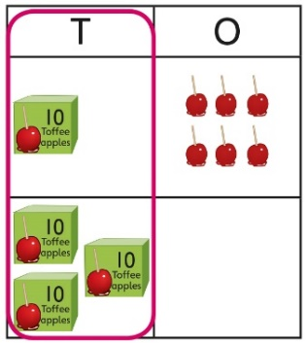  16 is 1 ten and 6 ones.  30 is 3 tens.  There are 4 tens and 6 ones in total. | Add the 10s using a place value grid to support.  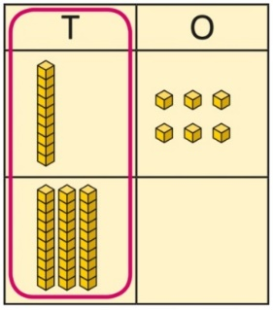  16 is 1 ten and 6 ones.  30 is 3 tens.  There are 4 tens and 6 ones in total. | Add the 10s represented vertically. Children must understand how the method relates to unitising of 10s and place value.  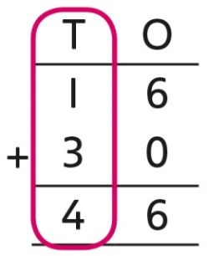  1 + 3 = 4  1 ten + 3 tens = 4 tens  16 + 30 = 46
Adding two  2-digit numbers | Add the 10s and 1s separately.  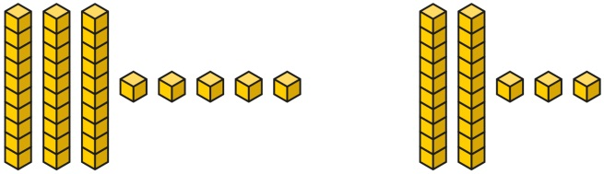  5 + 3 = 8  There are 8 ones in total.  3 + 2 = 5  There are 5 tens in total.  35 + 23 = 58 | Add the 10s and 1s separately. Use a  part-whole model to support.  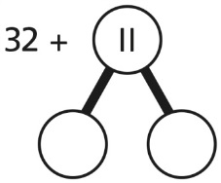  11 = 10 + 1  32 + 10 = 42  42 + 1 = 43  32 + 11 = 43 | Add the 10s and the 1s separately, bridging 10s where required. A number line can support the calculations.  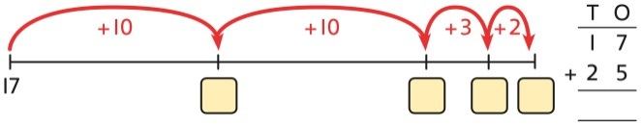  17 + 25
Adding two  2-digit numbers using a place value grid | Add the 1s. Then add the 10s.  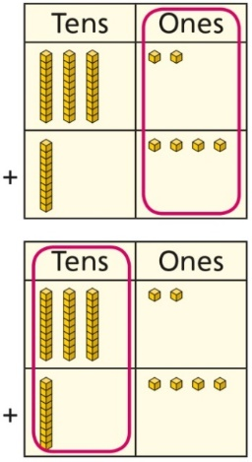 |  | Add the 1s. Then add the 10s.  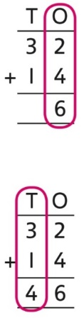
Adding two  2-digit numbers with exchange | Add the 1s. Exchange 10 ones for a ten. Then add the 10s.  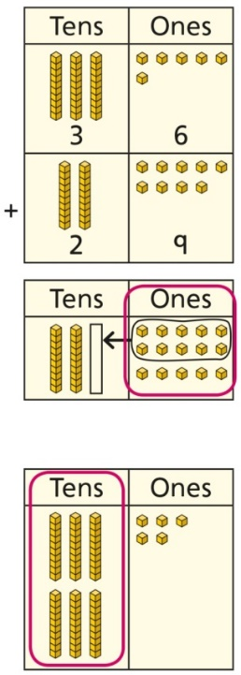 |  | Add the 1s. Exchange 10 ones for a ten. Then add the 10s.  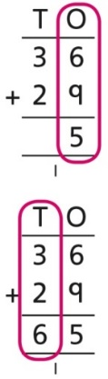
Year 2
Subtraction
Subtracting multiples of 10 | Use known number bonds and unitising to subtract multiples of 10.  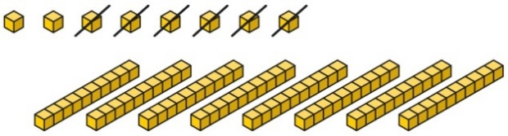  8 subtract 6 is 2.  So, 8 tens subtract 6 tens is 2 tens. | Use known number bonds and unitising to subtract multiples of 10.  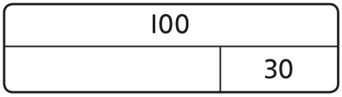  10 − 3 = 7  So, 10 tens subtract 3 tens is 7 tens. | Use known number bonds and unitising to subtract multiples of 10.  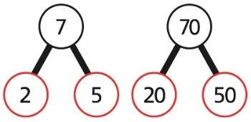  7 tens subtract 5 tens is 2 tens.  70 − 50 = 20
Subtracting a single-digit number | Subtract the 1s. This may be done in or out of a place value grid.  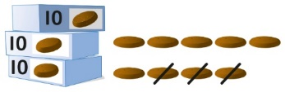  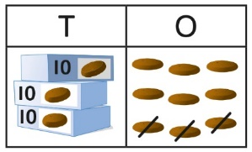 | Subtract the 1s. This may be done in or out of a place value grid.  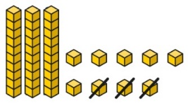  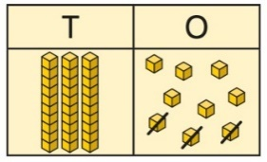 | Subtract the 1s. Understand the link between counting back and subtracting the 1s using known bonds.  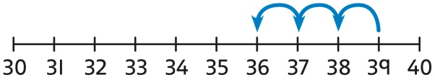  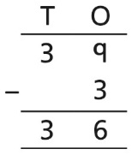 9 − 3 = 6  39 − 3 = 36
Subtracting a single-digit number bridging 10 | Bridge 10 by using known bonds.  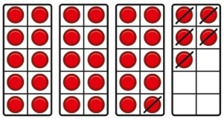  35 − 6  I took away 5 counters, then 1 more. | Bridge 10 by using known bonds.  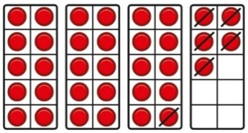  35 − 6  First, I will subtract 5, then 1. | Bridge 10 by using known bonds.  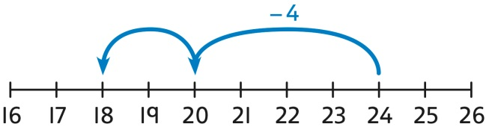  24 − 6 = ?  24 − 4 − 2 = ?
Subtracting a single-digit number using exchange | Exchange 1 ten for 10 ones. This may be done in or out of a place value grid.  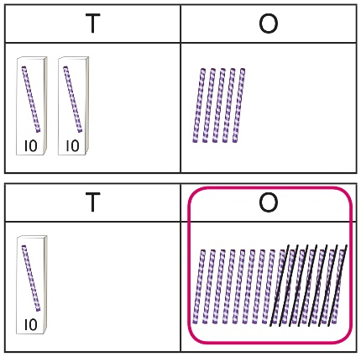 | Exchange 1 ten for 10 ones.  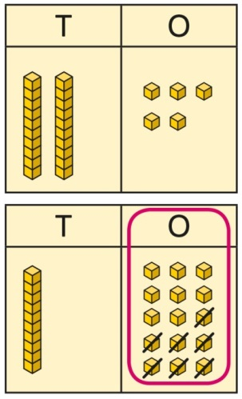 | Exchange 1 ten for 10 ones.  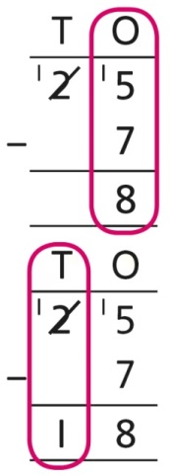  25 − 7 = 18
Subtracting a  2-digit number | Subtract by taking away.  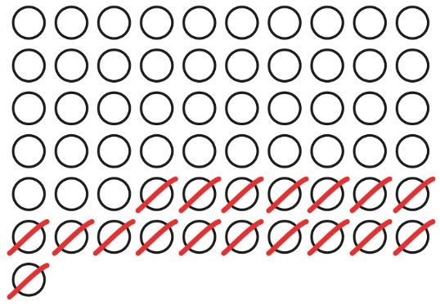  61 − 18  I took away 1 ten and 8 ones. | Subtract the 10s and the 1s.  This can be represented on a 100 square.  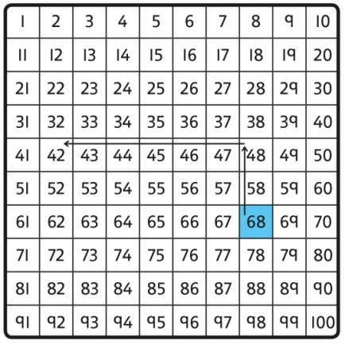 | Subtract the 10s and the 1s.  This can be represented on a number line.  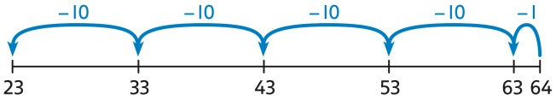  64 − 41 = ?  64 − 1 = 63  63 − 40 = 23  64 − 41 = 23  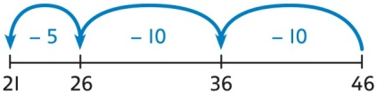  46 − 20 = 26  26 − 5 = 21  46 − 25 = 21
Subtracting a  2-digit number using place value and columns | Subtract the 1s. Then subtract the 10s. This may be done in or out of a place value grid.  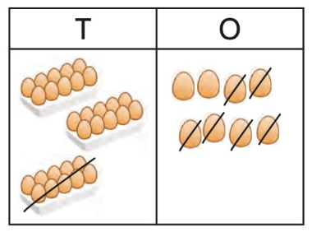  38 − 16 = 22 | Subtract the 1s. Then subtract the 10s.  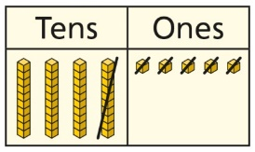 | Using column subtraction, subtract the 1s. Then subtract the 10s.  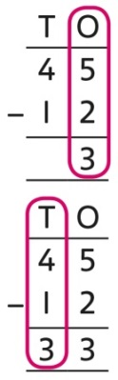
Subtracting a  2-digit number with exchange |  | Exchange 1 ten for 10 ones. Then subtract the 1s. Then subtract the 10s.  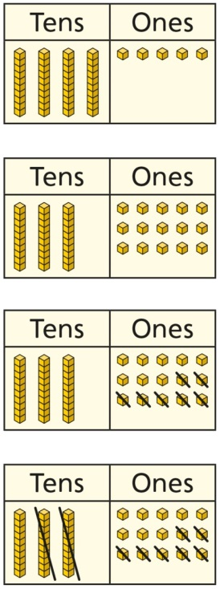 | Using column subtraction, exchange 1 ten for 10 ones. Then subtract the 1s. Then subtract the 10s.  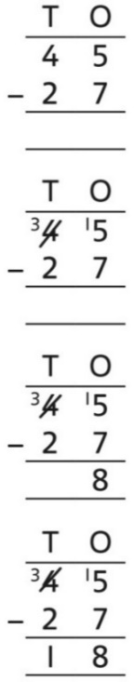
Year 2
Multiplication
Equal groups and repeated addition | Recognise equal groups and write as repeated addition and as multiplication.  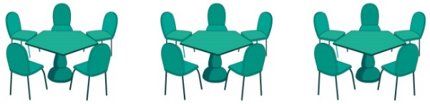  3 groups of 5 chairs  15 chairs altogether | Recognise equal groups using standard objects such as counters and write as repeated addition and multiplication.  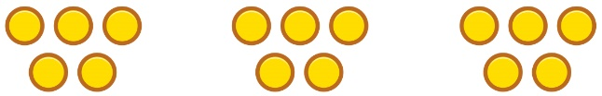  3 groups of 5  15 in total | Use a number line and write as repeated addition and as multiplication.  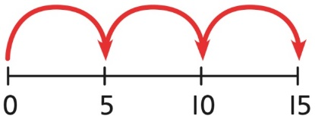  5 + 5 + 5 = 15  3 × 5 = 15
Using arrays to represent multiplication and support understanding | Understand the relationship between arrays, multiplication and repeated addition.  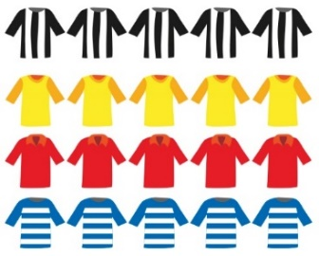  4 groups of 5 | Understand the relationship between arrays, multiplication and repeated addition.  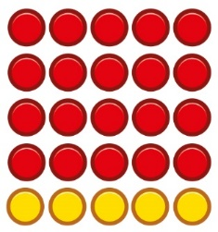  4 groups of 5 … 5 groups of 5 | Understand the relationship between arrays, multiplication and repeated addition.  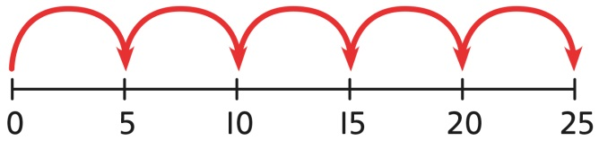  5 × 5 = 25
Understanding commutativity | Use arrays to visualise commutativity.  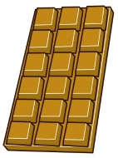  I can see 6 groups of 3.  I can see 3 groups of 6. | Form arrays using counters to visualise commutativity. Rotate the array to show that orientation does not change the multiplication.  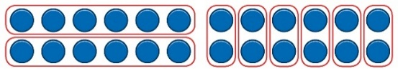  This is 2 groups of 6 and also 6 groups of 2. | Use arrays to visualise commutativity.  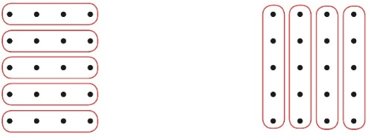  4 + 4 + 4 + 4 + 4 = 20  5 + 5 + 5 + 5 = 20  4 × 5 = 20 and 5 × 4 = 20
Learning ×2, ×5 and ×10 table facts | Develop an understanding of how to unitise groups of 2, 5 and 10 and learn corresponding times-table facts.  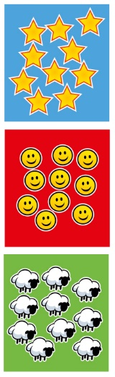  3 groups of 10 … 10, 20, 30  3 × 10 = 30 | Understand how to relate counting in unitised groups and repeated addition with knowing key times-table facts.  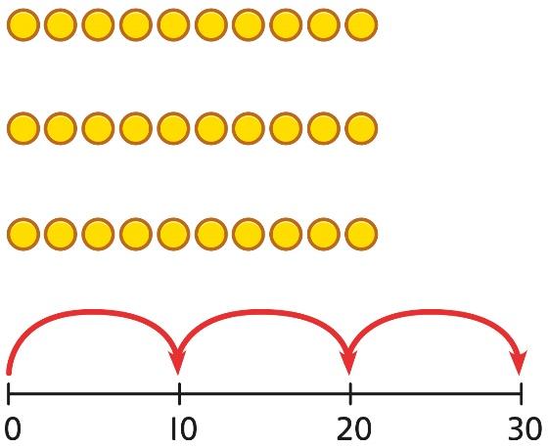  10 + 10 + 10 = 30  3 × 10 = 30 | Understand how the times-tables increase and contain patterns.  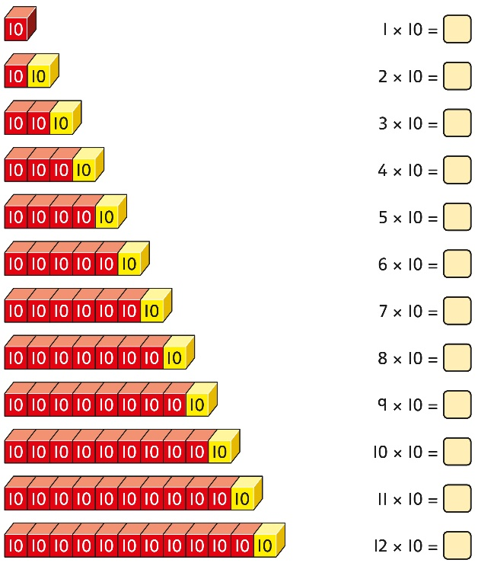  5 × 10 = 50  6 × 10 = 60
Year 2
Division
Sharing equally | Start with a whole and share into equal parts, one at a time.  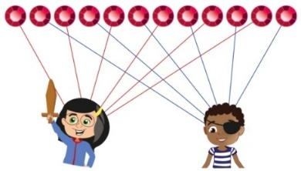  12 shared equally between 2.  They get 6 each.  Start to understand how this also relates to grouping. To share equally between 3 people, take a group of 3 and give 1 to each person. Keep going until all the objects have been shared  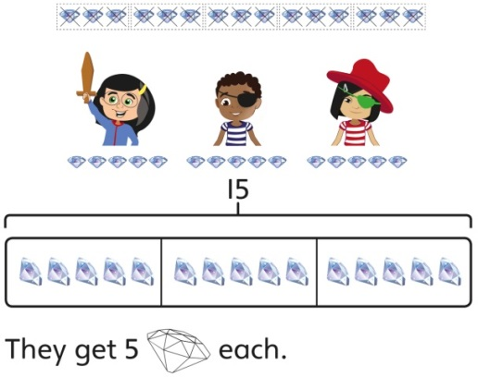  15 shared equally between 3.  They get 5 each. | Represent the objects shared into equal parts using a bar model.  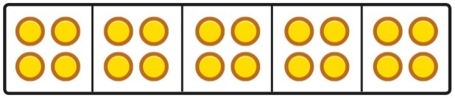  20 shared into 5 equal parts.  There are 4 in each part. | Use a bar model to support understanding of the division.  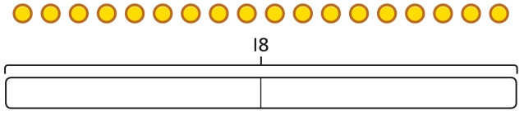  18 ÷ 2 = 9
Grouping equally | Understand how to make equal groups from a whole.  8 divided into 4 equal groups.  There are 2 in each group. | Understand the relationship between grouping and the division statements.  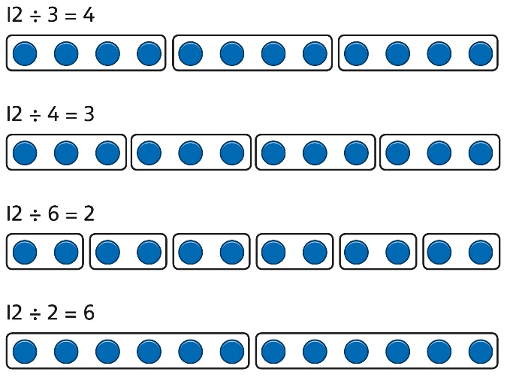 | Understand how to relate division by grouping to repeated subtraction.  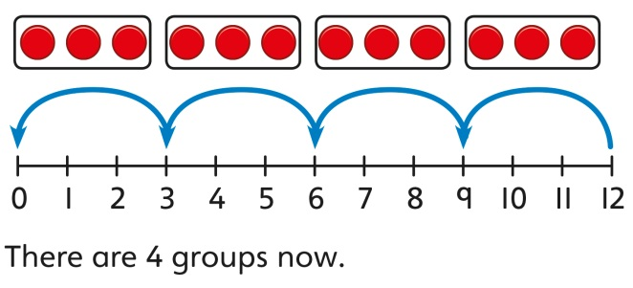  12 divided into groups of 3.  12 ÷ 3 = 4  There are 4 groups.
Using known times-tables to solve divisions | Understand the relationship between multiplication facts and division.  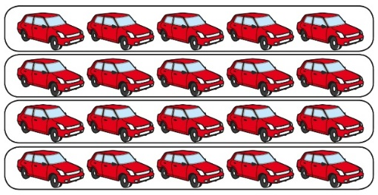  4 groups of 5 cars is 20 cars in total.  20 divided by 4 is 5. | Link equal grouping with repeated subtraction and known times-table facts to support division.  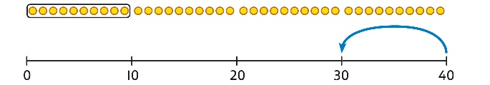  40 divided by 4 is 10.  Use a bar model to support understanding of the link between times-table knowledge and division.  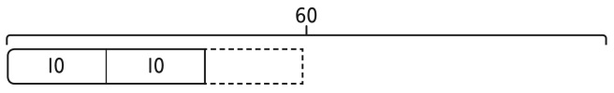 | Relate times-table knowledge directly to division.  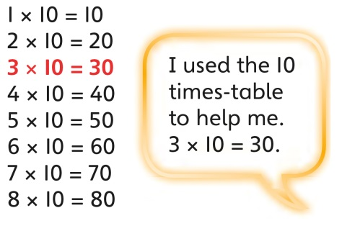  I know that 3 groups of 10 makes 30, so I know that 30 divided by 10 is 3.  3 × 10 = 30 so 30 ÷ 10 = 3

LOWER KEY STAGE 2
In Years 3 and 4, children develop the basis of written methods by building their skills alongside a deep understanding of place value. They should use known addition/subtraction and multiplication/division facts to calculate efficiently and accurately, rather than relying on counting. Children use place value equipment to support their understanding, but not as a substitute for thinking.
Key language: partition, place value, tens, hundreds, thousands, column method, whole, part, equal groups, sharing, grouping, bar model
Addition and subtraction: In Year 3 especially, the column methods are built up gradually. Children will develop their understanding of how each stage of the calculation, including any exchanges, relates to place value. The example calculations chosen to introduce the stages of each method may often be more suited to a mental method. However, the examples and the progression of the steps have been chosen to help children develop their fluency in the process, alongside a deep understanding of the concepts and the numbers involved, so that they can apply these skills accurately and efficiently to later calculations. The class should be encouraged to compare mental and written methods for specific calculations, and children should be encouraged at every stage to make choices about which methods to apply.  In Year 4, the steps are shown without such fine detail, although children should continue to build their understanding with a secure basis in place value. In subtraction, children will need to develop their understanding of exchange as they may need to exchange across one or two columns.  By the end of Year 4, children should have developed fluency in column methods alongside a deep understanding, which will allow them to progress confidently in upper Key Stage 2. | Multiplication and division: Children build a solid grounding in times-tables, understanding the multiplication and division facts in tandem. As such, they should be as confident knowing that 35 divided by 7 is 5 as knowing that 5 times 7 is 35.  Children develop key skills to support multiplication methods: unitising, commutativity, and how to use partitioning effectively.  Unitising allows children to use known facts to multiply and divide multiples of 10 and 100 efficiently. Commutativity gives children flexibility in applying known facts to calculations and problem solving. An understanding of partitioning allows children to extend their skills to multiplying and dividing 2- and 3-digit numbers by a single digit.  Children develop column methods to support multiplications in these cases.  For successful division, children will need to make choices about how to partition. For example, to divide 423 by 3, it is effective to partition 423 into 300, 120 and 3, as these can be divided by 3 using known facts.  Children will also need to understand the concept of remainder, in terms of a given calculation and in terms of the context of the problem. | Fractions: Children develop the key concept of equivalent fractions, and link this with multiplying and dividing the numerators and denominators, as well as exploring the visual concept through fractions of shapes. Children learn how to find a fraction of an amount, and develop this with the aid of a bar model and other representations alongside.  in Year 3, children develop an understanding of how to add and subtract fractions with the same denominator and find complements to the whole. This is developed alongside an understanding of fractions as numbers, including fractions greater than 1. In Year 4, children begin to work with fractions greater than 1.  Decimals are introduced, as tenths in Year 3 and then as hundredths in Year 4. Children develop an understanding of decimals in terms of the relationship with fractions, with dividing by 10 and 100, and also with place value.

Year 3
 | Concrete | Pictorial | Abstract
Year 3
Addition
Understanding 100s | Understand the cardinality of 100, and the link with 10 tens.  Use cubes to place into groups of 10 tens.  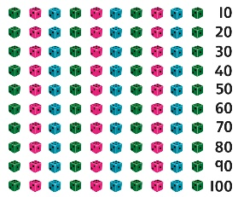 | Unitise 100 and count in steps of 100.  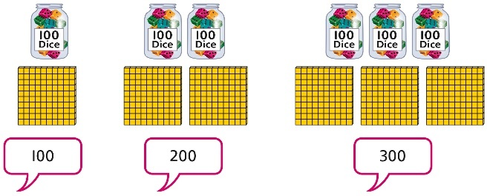 | Represent steps of 100 on a number line and a number track and count up to 1,000 and back to 0.  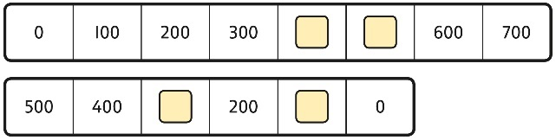
Understanding place value to 1,000 | Unitise 100s, 10s and 1s to build 3-digit numbers.  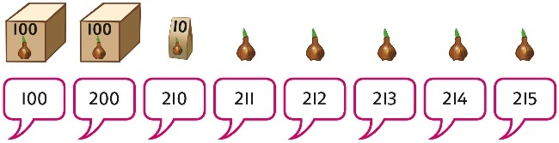 | Use equipment to represent numbers to 1,000.  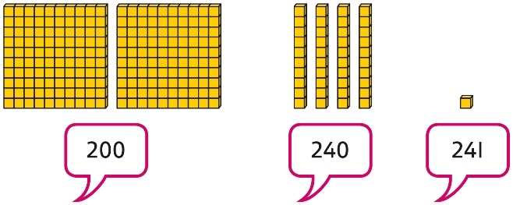  Use a place value grid to support the structure of numbers to 1,000.  Place value counters are used alongside other equipment. Children should understand how each counter represents a different unitised amount. | Represent the parts of numbers to 1,000 using a part-whole model.  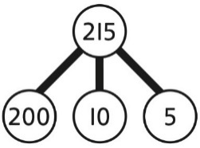  215 = 200 + 10 + 5  Recognise numbers to 1,000 represented on a number line, including those between intervals.
Adding 100s | Use known facts and unitising to add multiples of 100.  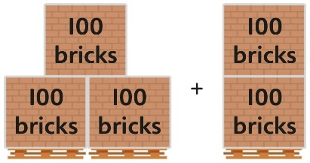  3 + 2 = 5  3 hundreds + 2 hundreds = 5 hundreds  300 + 200 = 500 | Use known facts and unitising to add multiples of 100.  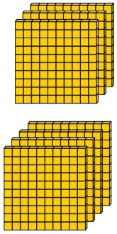  3 + 4 = 7  3 hundreds + 4 hundreds = 7 hundreds  300 + 400 = 700 | Use known facts and unitising to add multiples of 100.  Represent the addition on a number line.  Use a part-whole model to support unitising.  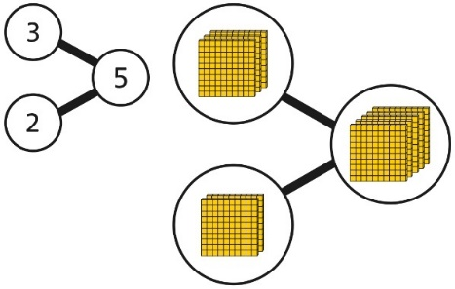  3 + 2 = 5  300 + 200 = 500
3-digit number + 1s, no exchange or bridging | Use number bonds to add the 1s.  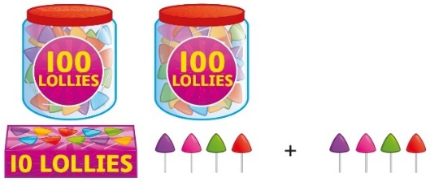  214 + 4 = ?  Now there are 4 + 4 ones in total.  4 + 4 = 8  214 + 4 = 218 | Use number bonds to add the 1s.  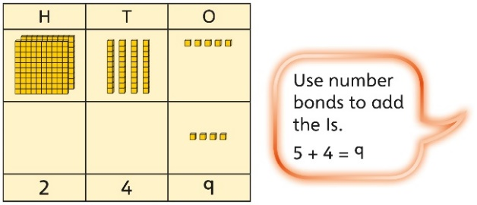  245 + 4  5 + 4 = 9  245 + 4 = 249 | Understand the link with counting on.  245 + 4  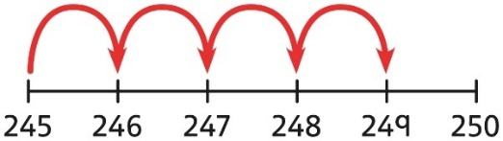  Use number bonds to add the 1s and understand that this is more efficient and less prone to error.  245 + 4 = ?  I will add the 1s.  5 + 4 = 9  So, 245 + 4 = 249
3-digit number + 1s with exchange | Understand that when the 1s sum to 10 or more, this requires an exchange of 10 ones for 1 ten.  Children should explore this using unitised objects or physical apparatus. | Exchange 10 ones for 1 ten where needed. Use a place value grid to support the understanding.  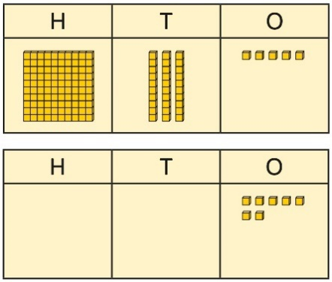  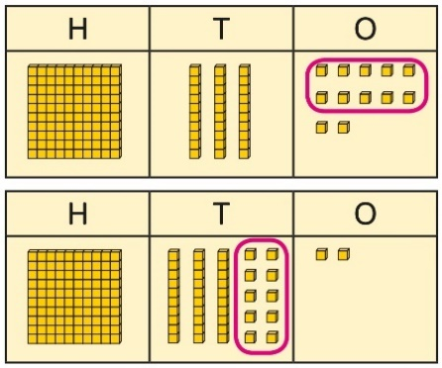  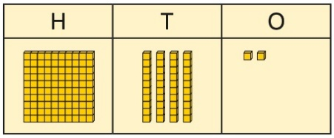  135 + 7 = 142 | Understand how to bridge by partitioning to the 1s to make the next 10.  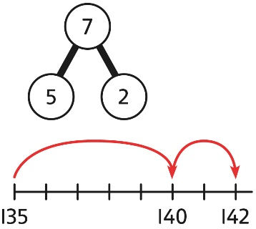  135 + 7 = ?  135 + 5 + 2 = 142  Ensure that children understand how to add 1s bridging a 100.  198 + 5 = ?  198 + 2 + 3 = 203
3-digit number + 10s, no exchange | Calculate mentally by forming the number bond for the 10s.  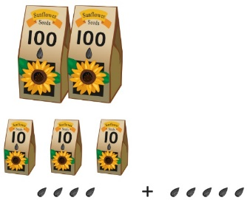  234 + 50  There are 3 tens and 5 tens altogether.  3 + 5 = 8  In total there are 8 tens.  234 + 50 = 284 | Calculate mentally by forming the number bond for the 10s.  351 + 30 = ?  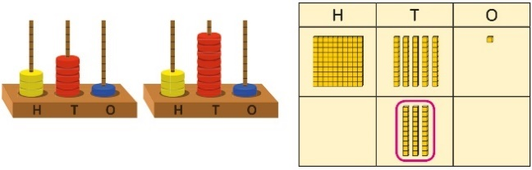  5 tens + 3 tens = 8 tens  351 + 30 = 381 | Calculate mentally by forming the number bond for the 10s.  753 + 40  I know that 5 + 4 = 9  So, 50 + 40 = 90  753 + 40 = 793
3-digit number + 10s, with exchange | Understand the exchange of 10 tens for 1 hundred.  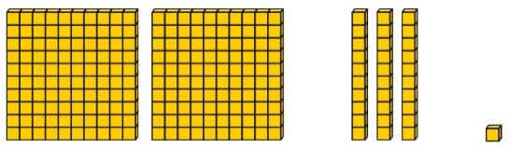 | Add by exchanging 10 tens for 1 hundred.  184 + 20 = ?  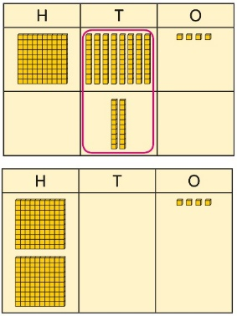  184 + 20 = 204 | Understand how the addition relates to counting on in 10s across 100.  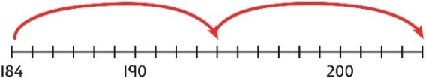  184 + 20 = ?  I can count in 10s … 194 … 204  184 + 20 = 204  Use number bonds within 20 to support efficient mental calculations.  385 + 50  There are 8 tens and 5 tens.  That is 13 tens.  385 + 50 = 300 + 130 + 5  385 + 50 = 435
3-digit number + 2-digit number | Use place value equipment to make and combine groups to model addition.  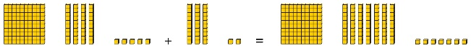 | Use a place value grid to organise thinking and adding of 1s, then 10s. | Use the vertical column method to represent the addition. Children must understand how this relates to place value at each stage of the calculation.
3-digit number + 2-digit number, exchange required | Use place value equipment to model addition and understand where exchange is required.  Use place value counters to represent  154 + 72.  Use this to decide if any exchange is required.  There are 5 tens and 7 tens. That is 12 tens so I will exchange. | Represent the required exchange on a place value grid using equipment.  275 + 16 = ?  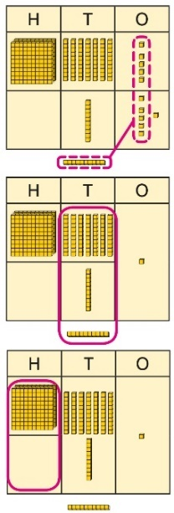  275 + 16 = 291  Note: In this example, a mental method may be more efficient. The numbers for the example calculation have been chosen to allow children to visualise the concept and see how the method relates to place value.  Children should be encouraged at every stage to select methods that are accurate and efficient. | Use a column method with exchange. Children must understand how the method relates to place value at each stage of the calculation.  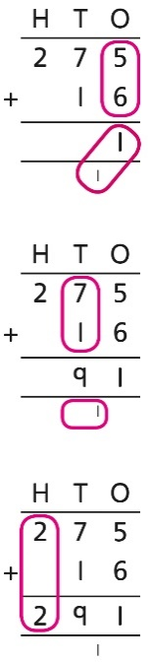  275 + 16 = 291
3-digit number + 3-digit number, no exchange | Use place value equipment to make a representation of a calculation. This may or may not be structured in a place value grid.  326 + 541 is represented as:  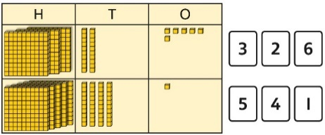 | Represent the place value grid with equipment to model the stages of column addition. | Use a column method to solve efficiently, using known bonds. Children must understand how this relates to place value at every stage of the calculation.
3-digit number + 3-digit number, exchange required | Use place value equipment to enact the exchange required.  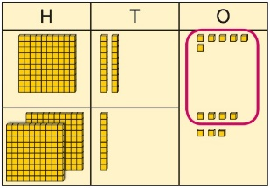  There are 13 ones.  I will exchange 10 ones for 1 ten. | Model the stages of column addition using place value equipment on a place value grid.  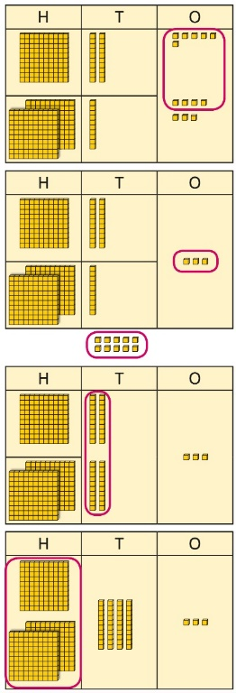 | Use column addition, ensuring understanding of place value at every stage of the calculation.  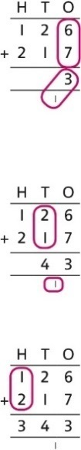  126 + 217 = 343  Note: Children should also study examples where exchange is required in more than one column, for example 185 + 318 = ?
Representing addition problems, and selecting appropriate methods | Encourage children to use their own drawings and choices of place value equipment to represent problems with one or more steps.  These representations will help them to select appropriate methods. | Children understand and create bar models to represent addition problems.  275 + 99 = ?  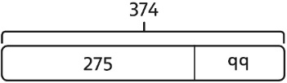  275 + 99 = 374 | Use representations to support choices of appropriate methods.  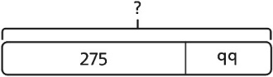  I will add 100, then subtract 1 to find the solution.  128 + 105 + 83 = ?  I need to add three numbers.  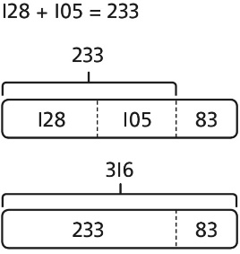
Year 3
Subtraction
Subtracting 100s | Use known facts and unitising to subtract multiples of 100.  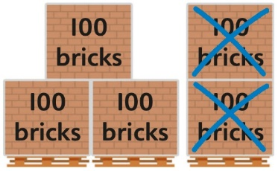  5 − 2 = 3  500 − 200 = 300 | Use known facts and unitising to subtract multiples of 100.  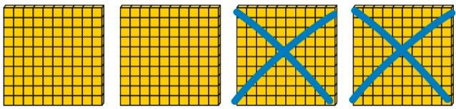  4 − 2 = 2  400 − 200 = 200 | Understand the link with counting back in 100s.  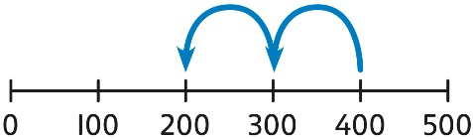  400 − 200 = 200  Use known facts and unitising as efficient and accurate methods.  I know that 7 − 4 = 3. Therefore, I know that 700 − 400 = 300.
3-digit number − 1s, no exchange | Use number bonds to subtract the 1s.  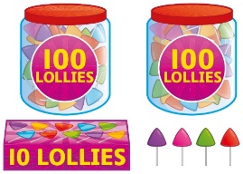  214 − 3 = ?  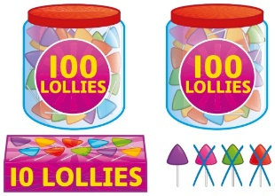  4 − 3 = 1  214 − 3 = 211 | Use number bonds to subtract the 1s.  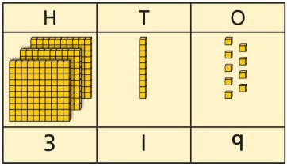  319 − 4 = ?  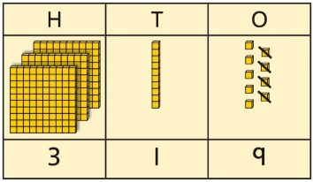  9 − 4 = 5  319 − 4 = 315 | Understand the link with counting back using a number line.  Use known number bonds to calculate mentally.  476 − 4 = ?  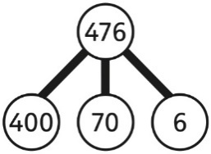  6 − 4 = 2  476 − 4 = 472
3-digit number − 1s, exchange or bridging required | Understand why an exchange is necessary by exploring why 1 ten must be exchanged.  Use place value equipment. | Represent the required exchange on a place value grid.  151 − 6 = ?  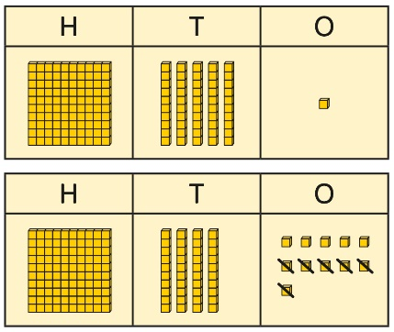 | Calculate mentally by using known bonds.  151 − 6 = ?  151 − 1 − 5 = 145
3-digit number − 10s, no exchange | Subtract the 10s using known bonds.  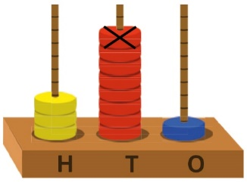  381 − 10 = ?  8 tens with 1 removed is 7 tens.  381 − 10 = 371 | Subtract the 10s using known bonds.  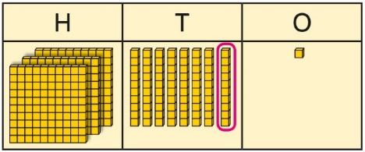  8 tens − 1 ten = 7 tens  381 − 10 = 371 | Use known bonds to subtract the 10s mentally.  372 − 50 = ?  70 − 50 = 20  So, 372 − 50 = 322
3-digit number − 10s, exchange or bridging required | Use equipment to understand the exchange of 1 hundred for 10 tens.  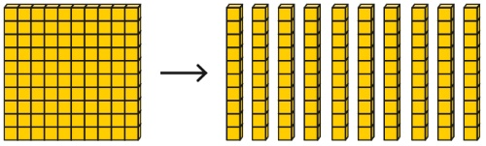 | Represent the exchange on a place value grid using equipment.  210 − 20 = ?  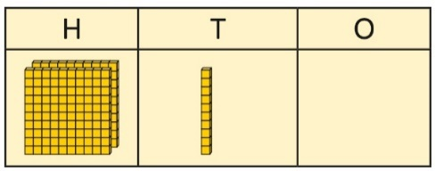  I need to exchange 1 hundred for 10 tens, to help subtract 2 tens.  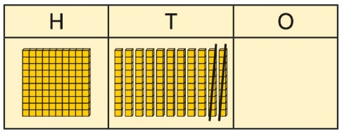  210 − 20 = 190 | Understand the link with counting back on a number line.  Use flexible partitioning to support the calculation.  235 − 60 = ?  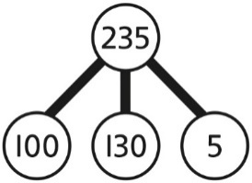  235 = 100 + 130 + 5  235 − 60 = 100 + 70 + 5  = 175
3-digit number − up to 3-digit number | Use place value equipment to explore the effect of splitting a whole into two parts, and understand the link with taking away.  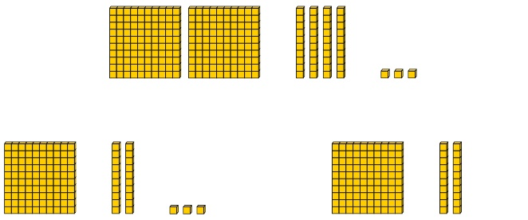 | Represent the calculation on a place value grid.  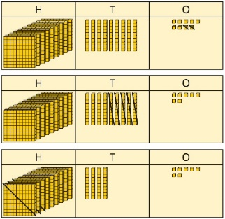 | Use column subtraction to calculate accurately and efficiently.  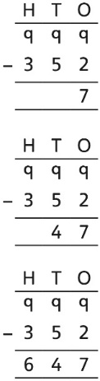
3-digit number − up to 3-digit number, exchange required | Use equipment to enact the exchange of 1 hundred for 10 tens, and 1 ten for 10 ones.  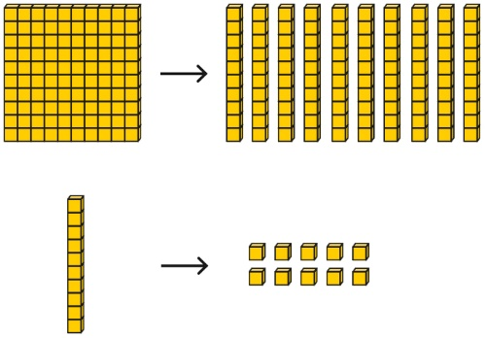 | Model the required exchange on a place value grid.  175 − 38 = ?  I need to subtract 8 ones, so I will exchange a ten for 10 ones.  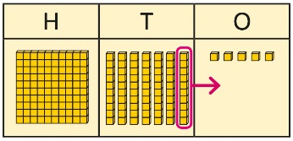  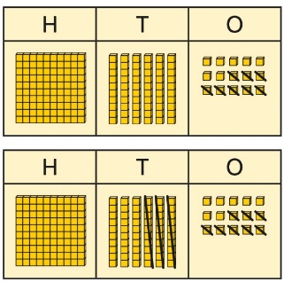 | Use column subtraction to work accurately and efficiently.  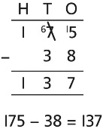  If the subtraction is a 3-digit number subtract a 2-digit number, children should understand how the recording relates to the place value, and so how to line up the digits correctly.  Children should also understand how to exchange in calculations where there is a zero in the 10s column.  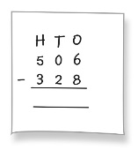
Representing subtraction problems |  | Use bar models to represent subtractions.  ‘Find the difference’ is represented as two bars for comparison.  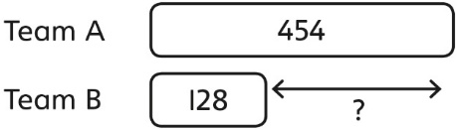  Bar models can also be used to show that a part must be taken away from the whole. | Children use alternative representations to check calculations and choose efficient methods.  Children use inverse operations to check additions and subtractions.  The part-whole model supports understanding.  I have completed this subtraction.  525 − 270 = 255  I will check using addition.  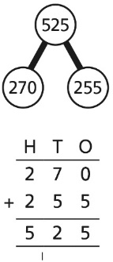
Year 3
Multiplication
Understanding equal grouping and repeated addition | Children continue to build understanding of equal groups and the relationship with repeated addition.  They recognise both examples and non-examples using objects.  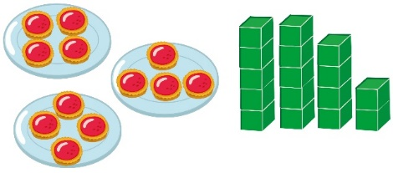  Children recognise that arrays can be used to model commutative multiplications.  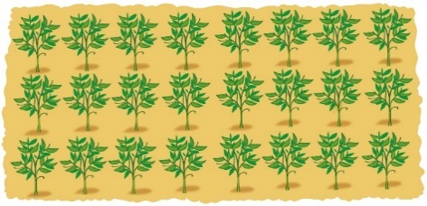  I can see 3 groups of 8.  I can see 8 groups of 3. | Children recognise that arrays demonstrate commutativity.  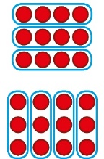  This is 3 groups of 4.  This is 4 groups of 3. | Children understand the link between repeated addition and multiplication.  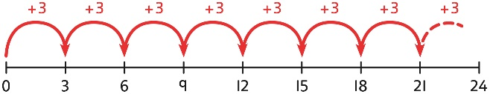  8 groups of 3 is 24.  3 + 3 + 3 + 3 + 3 + 3 + 3 + 3 = 24  8 × 3 = 24  A bar model may represent multiplications as equal groups.  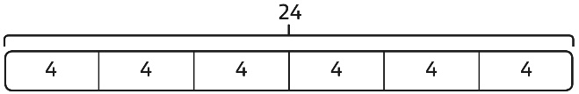  6 × 4 = 24
Using commutativity to support understanding of the times-tables | Understand how to use times-tables facts flexibly.  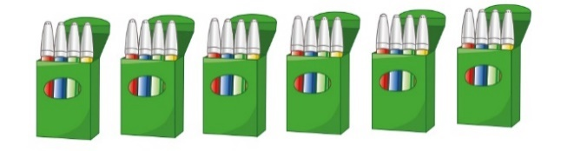  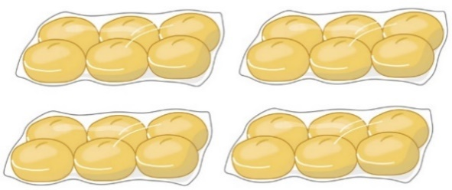  There are 6 groups of 4 pens.  There are 4 groups of 6 bread rolls.  I can use 6 × 4 = 24 to work out both totals. | Understand how times-table facts relate to commutativity.  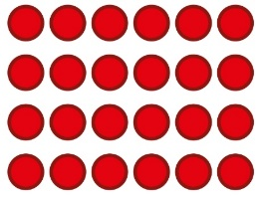  6 × 4 = 24  4 × 6 = 24 | Understand how times-table facts relate to commutativity.  I need to work out 4 groups of 7.  I know that 7 × 4 = 28  so, I know that  4 groups of 7 = 28  and  7 groups of 4 = 28.
Understanding and using ×3, ×2, ×4 and ×8 tables. | Children learn the times-tables as ‘groups of’, but apply their knowledge of commutativity.  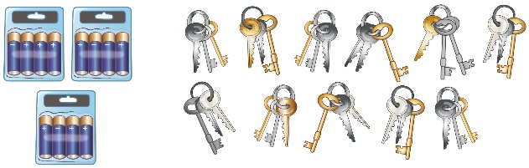  I can use the ×3 table to work out how many keys.  I can also use the ×3 table to work out how many batteries. | Children understand how the ×2, ×4 and ×8 tables are related through repeated doubling.  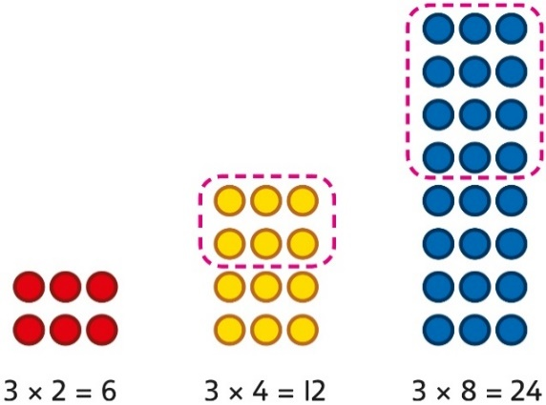 | Children understand the relationship between related multiplication and division facts in known times-tables.  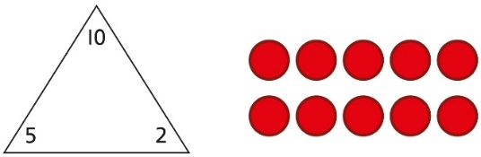  2 × 5 = 10  5 × 2 = 10  10 ÷ 5 = 2  10 ÷ 2 = 5
Using known facts to multiply 10s, for example  3 × 40 | Explore the relationship between known times-tables and multiples of 10 using place value equipment.  Make 4 groups of 3 ones.  Make 4 groups of 3 tens.  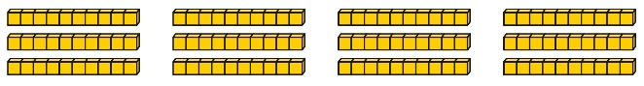  What is the same?  What is different? | Understand how unitising 10s supports multiplying by multiples of 10.  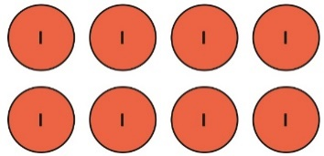  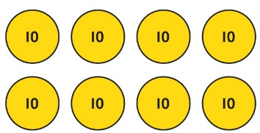  4 groups of 2 ones is 8 ones.  4 groups of 2 tens is 8 tens.  4 × 2 = 8  4 × 20 = 80 | Understand how to use known times-tables to multiply multiples of 10.  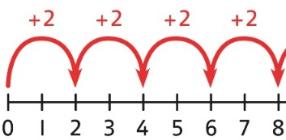  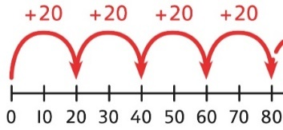  4 × 2 = 8  4 × 20 = 80
Multiplying a  2-digit number by a 1-digit number | Understand how to link partitioning a 2-digit number with multiplying.  Each person has 23 flowers.  Each person has 2 tens and 3 ones.  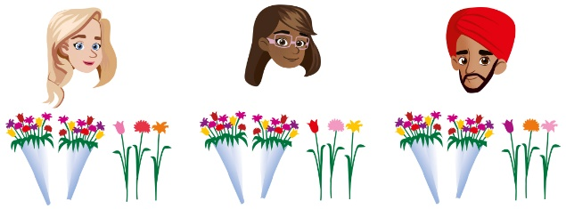  There are 3 groups of 2 tens.  There are 3 groups of 3 ones.  Use place value equipment to model the multiplication context.  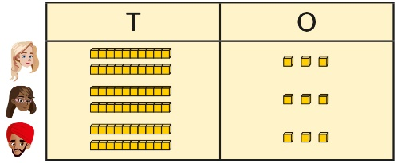  There are 3 groups of 3 ones.  There are 3 groups of 2 tens. | Use place value to support how partitioning is linked with multiplying by a 2-digit number.  3 × 24 = ?  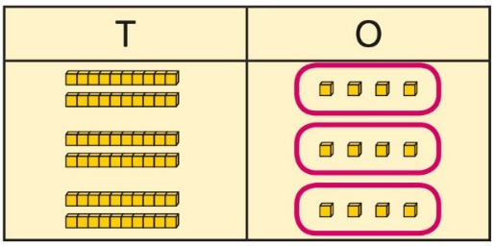  3 × 4 = 12  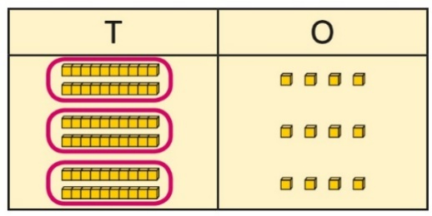  3 × 20 = 60  60 + 12 = 72  3 × 24 = 72 | Use addition to complete multiplications of 2-digit numbers by a 1-digit number.  4 × 13 = ?  4 × 3 = 12 4 × 10 = 40  12 + 40 = 52  4 × 13 = 52
Multiplying a  2-digit number by a 1-digit number, expanded column method | Use place value equipment to model how 10 ones are exchanged for a 10 in some multiplications.  3 × 24 = ?  3 × 20 = 60  3 × 4 = 12  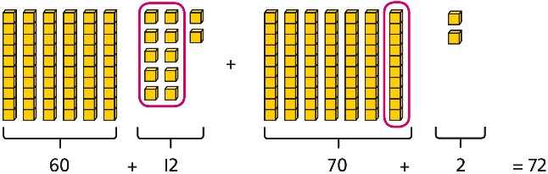  3 × 24 = 60 + 12  3 × 24 = 70 + 2  3 × 24 = 72 | Understand that multiplications may require an exchange of 1s for 10s, and also 10s for 100s.  4 × 23 = ?  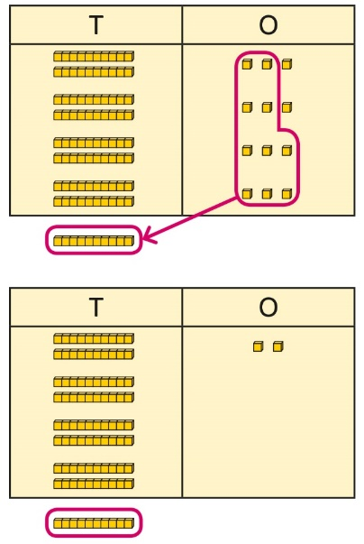  4 × 23 = 92  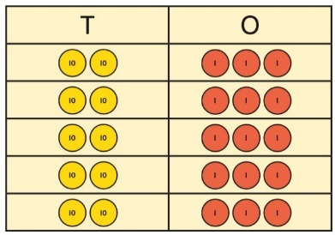  5 × 23 = ?  5 × 3 = 15  5 × 20 = 100  5 × 23 = 115 | Children may write calculations in expanded column form, but must understand the link with place value and exchange.  Children are encouraged to write the expanded parts of the calculation separately.  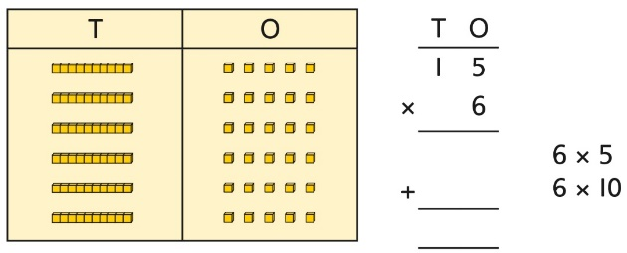  5 × 28 = ?  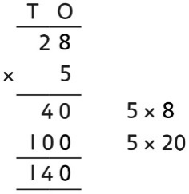
Year 3
Division
Using times-tables knowledge to divide | Use knowledge of known times-tables to calculate divisions.  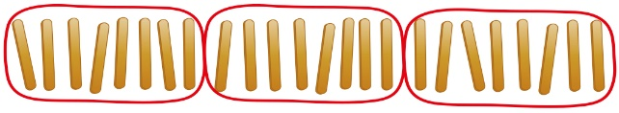  24 divided into groups of 8.  There are 3 groups of 8. | Use knowledge of known times-tables to calculate divisions.  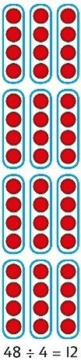  48 divided into groups of 4.  There are 12 groups.  4 × 12 = 48  48 ÷ 4 = 12 | Use knowledge of known times-tables to calculate divisions.  I need to work out 30 shared between 5.  I know that 6 × 5 = 30  so I know that 30 ÷ 5 = 6.  A bar model may represent the relationship between sharing and grouping.  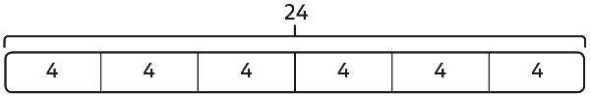  24 ÷ 4 = 6  24 ÷ 6 = 4  Children understand how division is related to both repeated subtraction and repeated addition.  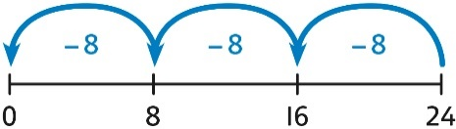  24 ÷ 8 = 3  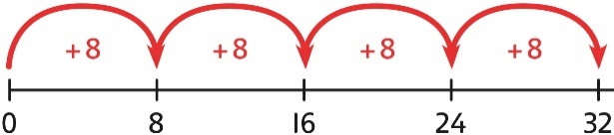  32 ÷ 8 = 4
Understanding remainders | Use equipment to understand that a remainder occurs when a set of objects cannot be divided equally any further.  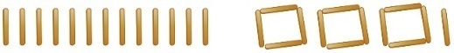  There are 13 sticks in total.  There are 3 groups of 4, with 1 remainder. | Use images to explain remainders.  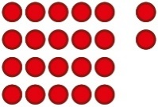  22 ÷ 5 = 4 remainder 2 | Understand that the remainder is what cannot be shared equally from a set.  22 ÷ 5 = ?  3 × 5 = 15  4 × 5 = 20  5 × 5 = 25 … this is larger than 22  So, 22 ÷ 5 = 4 remainder 2
Using known facts to divide multiples of 10 | Use place value equipment to understand how to divide by unitising.  Make 6 ones divided by 3.  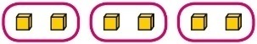  Now make 6 tens divided by 3.  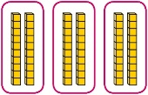  What is the same? What is different? | Divide multiples of 10 by unitising.  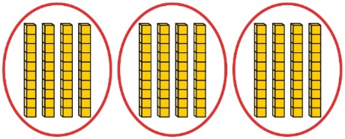  12 tens shared into 3 equal groups.  4 tens in each group. | Divide multiples of 10 by a single digit using known times-tables.  180 ÷ 3 = ?  180 is 18 tens.  18 divided by 3 is 6.  18 tens divided by 3 is 6 tens.  18 ÷ 3 = 6  180 ÷ 3 = 60
2-digit number divided by  1-digit number, no remainders | Children explore dividing 2-digit numbers by using place value equipment.  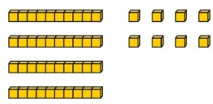  48 ÷ 2 = ?  First divide the 10s.  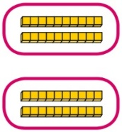  Then divide the 1s.  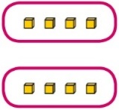 | Children explore which partitions support particular divisions.  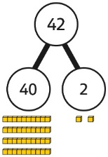  I need to partition 42 differently to divide by 3.  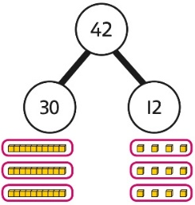  42 = 30 + 12  42 ÷ 3 = 14 | Children partition a number into 10s and 1s to divide where appropriate.  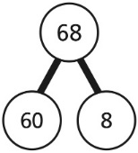  60 ÷ 2 = 30  8 ÷ 2 = 4  30 + 4 = 34  68 ÷ 2 = 34  Children partition flexibly to divide where appropriate.  42 ÷ 3 = ?  42 = 40 + 2  I need to partition 42 differently to divide  by 3.  42 = 30 + 12  30 ÷ 3 = 10  12 ÷ 3 = 4  10 + 4 = 14  42 ÷ 3 = 14
2-digit number divided by  1-digit number, with remainders | Use place value equipment to understand the concept of remainder.  Make 29 from place value equipment.  Share it into 2 equal groups.  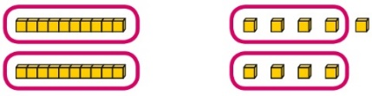  There are two groups of 14 and  1 remainder. | Use place value equipment to understand the concept of remainder in division.  29 ÷ 2 = ?  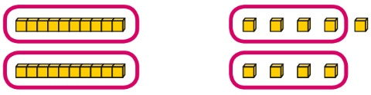  29 ÷ 2 = 14 remainder 1 | Partition to divide, understanding the remainder in context.  67 children try to make 5 equal lines.  67 = 50 + 17  50 ÷ 5 = 10  17 ÷ 5 = 3 remainder 2  67 ÷ 5 = 13 remainder 2  There are 13 children in each line and  2 children left out.
Year 4
 | Concrete | Pictorial | Abstract
Year 4
Addition
Understanding numbers to 10,000 | Use place value equipment to understand the place value of 4-digit numbers.  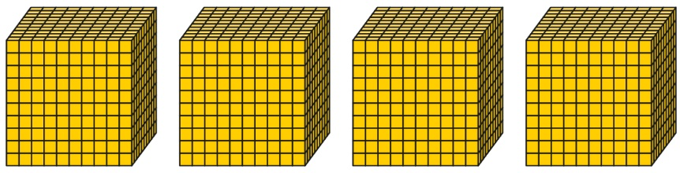  4 thousands equal 4,000.  1 thousand is 10 hundreds. | Represent numbers using place value counters once children understand the relationship between 1,000s and 100s.  2,000 + 500 + 40 + 2 = 2,542 | Understand partitioning of 4-digit numbers, including numbers with digits of 0.  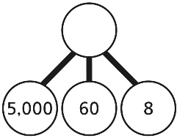  5,000 + 60 + 8 = 5,068  Understand and read 4-digit numbers on a number line.  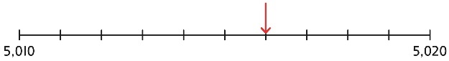
Choosing mental methods where appropriate | Use unitising and known facts to support mental calculations.  Make 1,405 from place value equipment.  Add 2,000.  Now add the 1,000s.  1 thousand + 2 thousands = 3 thousands  1,405 + 2,000 = 3,405 | Use unitising and known facts to support mental calculations.  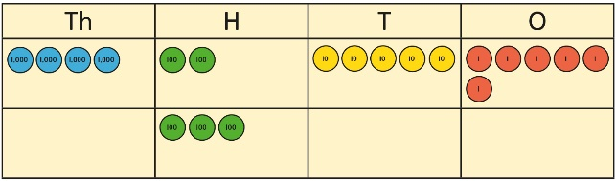  I can add the 100s mentally.  200 + 300 = 500  So, 4,256 + 300 = 4,556 | Use unitising and known facts to support mental calculations.  4,256 + 300 = ?  2 + 3 = 5 200 + 300 = 500  4,256 + 300 = 4,556
Column addition with exchange | Use place value equipment on a place value grid to organise thinking.  Ensure that children understand how the columns relate to place value and what to do if the numbers are not all 4-digit numbers.  Use equipment.to show 1,905 + 775.  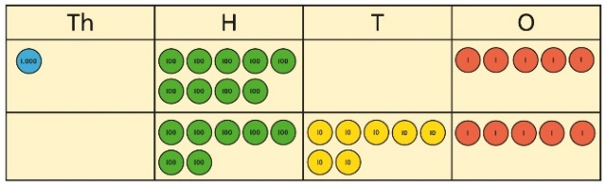  Why have only three columns been used for the second row? Why is the Thousands box empty?  Which columns will total 10 or more? | Use place value equipment to model required exchanges.  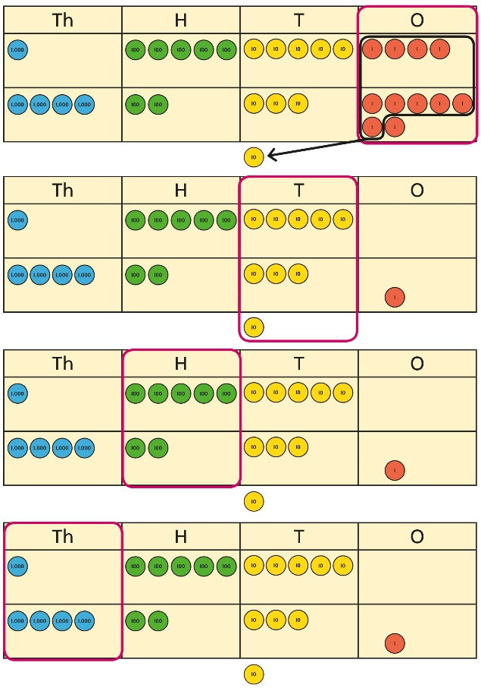  Include examples that exchange in more than one column. | Use a column method to add, including exchanges.  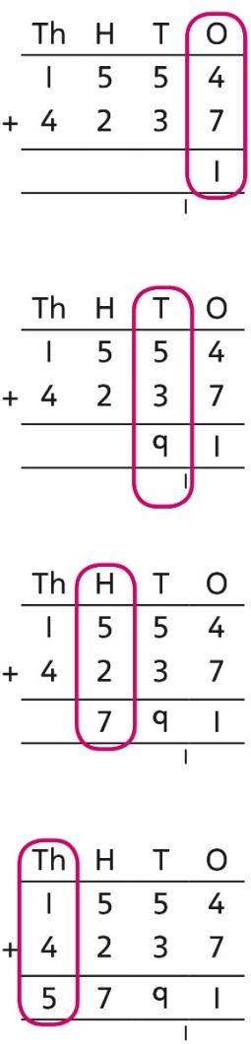  Include examples that exchange in more than one column.
Representing additions and checking strategies |  | Bar models may be used to represent additions in problem contexts, and to justify mental methods where appropriate.  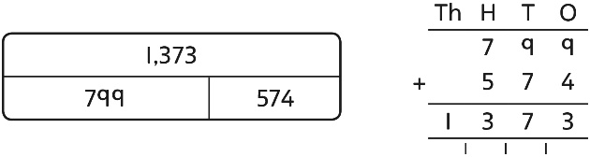  I chose to work out 574 + 800,  then subtract 1.  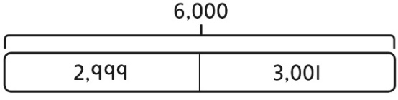  This is equivalent to 3,000 + 3,000. | Use rounding and estimating on a number line to check the reasonableness of an addition.  912 + 6,149 = ?  I used rounding to work out that the  answer should be approximately  1,000 + 6,000 = 7,000.
Year 4
Subtraction
Choosing mental methods where appropriate | Use place value equipment to justify mental methods.  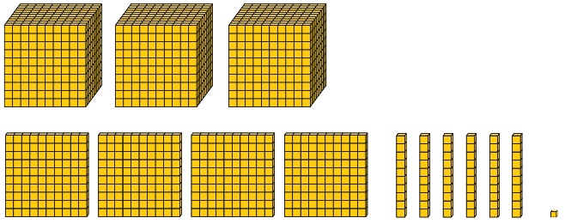  What number will be left if we take away 300? | Use place value grids to support mental methods where appropriate.  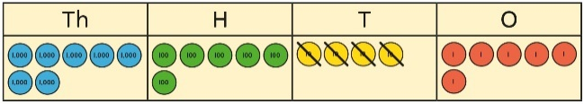  7,646 − 40 = 7,606 | Use knowledge of place value and unitising to subtract mentally where appropriate.  3,501 − 2,000  3 thousands − 2 thousands = 1 thousand  3,501 − 2,000 = 1,501
Column subtraction with exchange | Understand why exchange of a 1,000 for 100s, a 100 for 10s, or a 10 for 1s may be necessary.  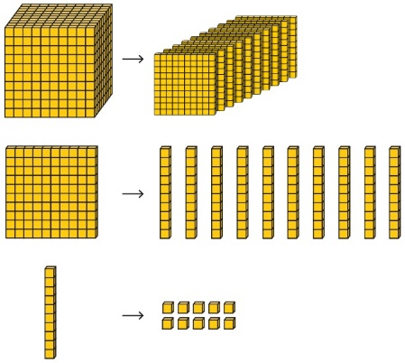 | Represent place value equipment on a place value grid to subtract, including exchanges where needed.  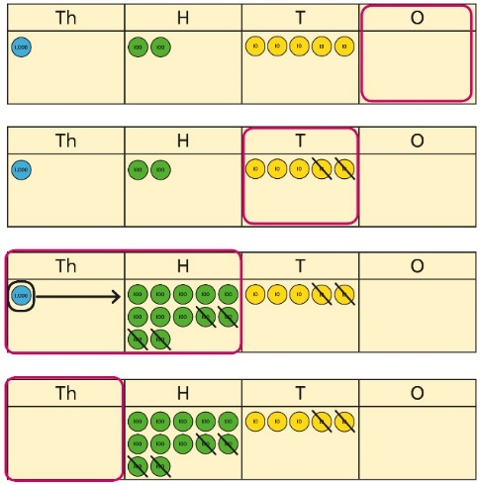 | Use column subtraction, with understanding of the place value of any exchange required.  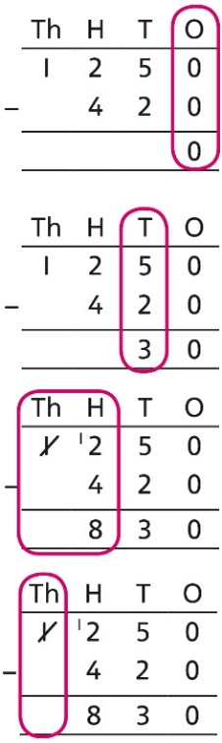
Column subtraction with exchange across more than one column | Understand why two exchanges may be necessary.  2,502 − 243 = ?  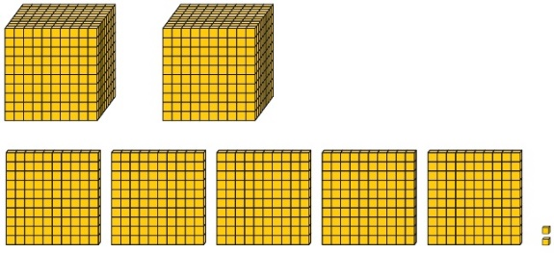  I need to exchange a 10 for some 1s, but there are not any 10s here.  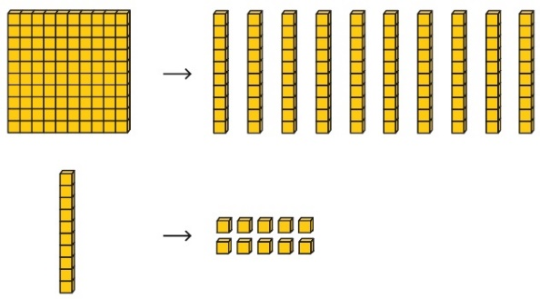 | Make exchanges across more than one column where there is a zero as a place holder.  2,502 − 243 = ?  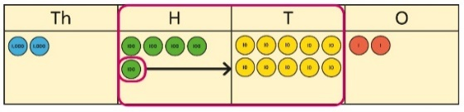  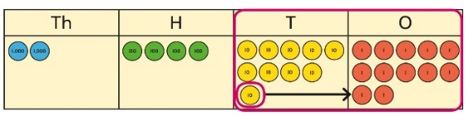 | Make exchanges across more than one column where there is a zero as a place holder.  2,502 − 243 = ?  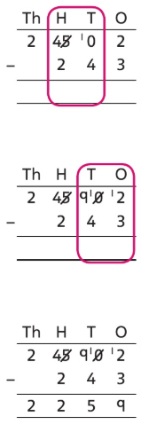
Representing subtractions and checking strategies |  | Use bar models to represent subtractions where a part needs to be calculated.  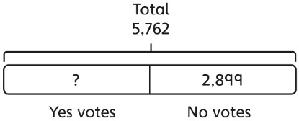  I can work out the total number of Yes votes using 5,762 − 2,899.  Bar models can also represent ‘find the difference’ as a subtraction problem.  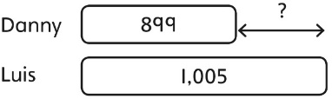 | Use inverse operations to check subtractions.  I calculated 1,225 − 799 = 574.  I will check by adding the parts.  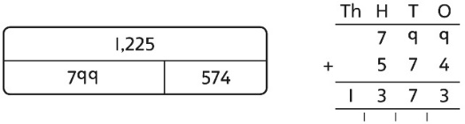  The parts do not add to make 1,225.  I must have made a mistake.
Year 4
Multiplication
Multiplying by multiples of 10 and 100 | Use unitising and place value equipment to understand how to multiply by multiples of 1, 10 and 100.  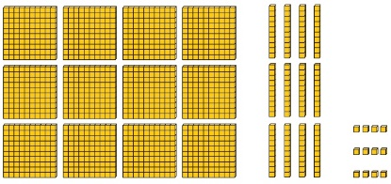  3 groups of 4 ones is 12 ones.  3 groups of 4 tens is 12 tens.  3 groups of 4 hundreds is 12 hundreds. | Use unitising and place value equipment to understand how to multiply by multiples of 1, 10 and 100.  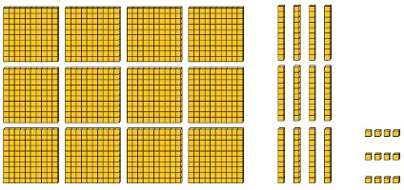  3 × 4 = 12  3 × 40 = 120  3 × 400 = 1,200 | Use known facts and understanding of place value and commutativity to multiply mentally.  4 × 7 = 28  4 × 70 = 280  40 × 7 = 280  4 × 700 = 2,800  400 × 7 = 2,800
Understanding times-tables up to 12 × 12 | Understand the special cases of multiplying by 1 and 0.  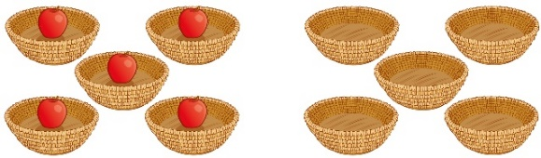  5 × 1 = 5 5 × 0 = 0 | Represent the relationship between the ×9 table and the ×10 table.  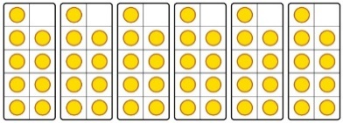  Represent the ×11 table and ×12 tables in relation to the ×10 table.  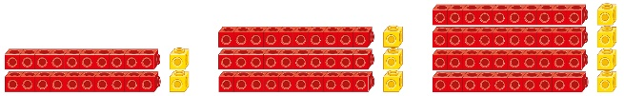  2 × 11 = 20 + 2  3 × 11 = 30 + 3  4 × 11 = 40 + 4  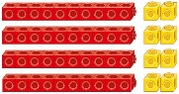  4 × 12 = 40 + 8 | Understand how times-tables relate to counting patterns.  Understand links between the  ×3 table, ×6 table and ×9 table  5 × 6 is double 5 × 3  ×5 table and ×6 table  I know that 7 × 5 = 35  so I know that 7 × 6 = 35 + 7.  ×5 table and ×7 table  3 × 7 = 3 × 5 + 3 × 2  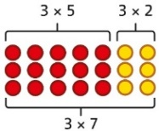  ×9 table and ×10 table  6 × 10 = 60  6 × 9 = 60 – 6
Understanding and using partitioning in multiplication | Make multiplications by partitioning.  4 × 12 is 4 groups of 10 and 4 groups of 2.  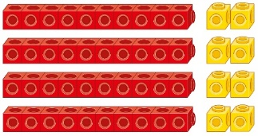  4 × 12 = 40 + 8 | Understand how multiplication and partitioning are related through addition.  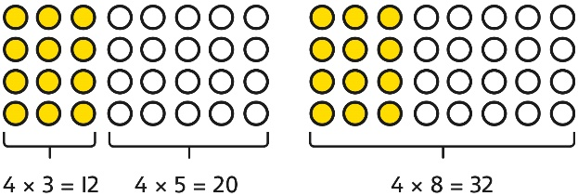  4 × 3 = 12  4 × 5 = 20  12 + 20 = 32  4 × 8 = 32 | Use partitioning to multiply 2-digit numbers by a single digit.  18 × 6 = ?  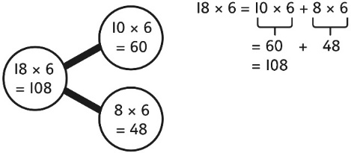  18 × 6 = 10 × 6 + 8 × 6  = 60 + 48  = 108
Column multiplication for 2- and  3-digit numbers multiplied by a single digit | Use place value equipment to make multiplications.  Make 4 × 136 using equipment.  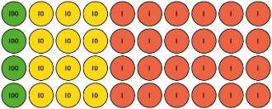  I can work out how many 1s, 10s and 100s.  There are 4 × 6 ones… 24 ones  There are 4 × 3 tens … 12 tens  There are 4 × 1 hundreds … 4 hundreds  24 + 120 + 400 = 544 | Use place value equipment alongside a column method for multiplication of up to  3-digit numbers by a single digit.  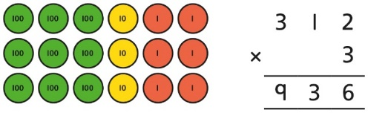 | Use the formal column method for up to  3-digit numbers multiplied by a single digit.  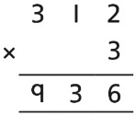  Understand how the expanded column method is related to the formal column method and understand how any exchanges are related to place value at each stage of the calculation.  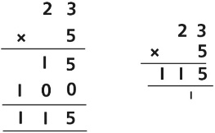
Multiplying more than two numbers | Represent situations by multiplying three numbers together.    Each sheet has 2 × 5 stickers.  There are 3 sheets.  There are 5 × 2 × 3 stickers in total.  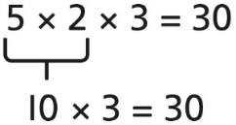 | Understand that commutativity can be used to multiply in different orders.  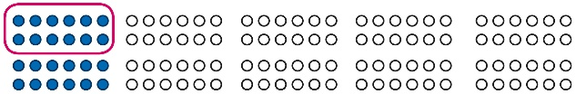  2 × 6 × 10 = 120  12 × 10 = 120  10 × 6 × 2 = 120  60 × 2 = 120 | Use knowledge of factors to simplify some multiplications.  24 × 5 = 12 × 2 × 5  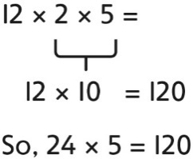
Year 4
Division
Understanding the relationship between multiplication and division, including times-tables | Use objects to explore families of multiplication and division facts.  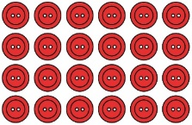  4 × 6 = 24  24 is 6 groups of 4.  24 is 4 groups of 6.  24 divided by 6 is 4.  24 divided by 4 is 6. | Represent divisions using an array.  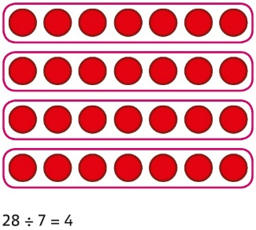 | Understand families of related multiplication and division facts.  I know that 5 × 7 = 35  so I know all these facts:  5 × 7 = 35  7 × 5 = 35  35 = 5 × 7  35 = 7 × 5  35 ÷ 5 = 7  35 ÷ 7 = 5  7 = 35 ÷ 5  5 = 35 ÷ 7
Dividing multiples of 10 and 100 by a single digit | Use place value equipment to understand how to use unitising to divide.  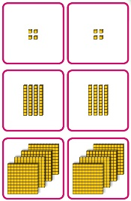  8 ones divided into 2 equal groups  4 ones in each group  8 tens divided into 2 equal groups  4 tens in each group  8 hundreds divided into 2 equal groups  4 hundreds in each group | Represent divisions using place value equipment.  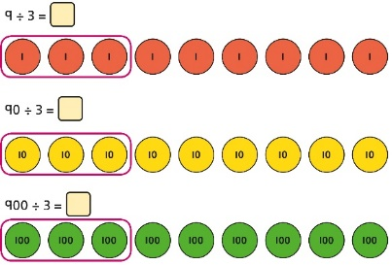  9 ÷ 3 = 3  9 tens divided by 3 is 3 tens.  9 hundreds divided by 3 is 3 hundreds. | Use known facts to divide 10s and 100s by a single digit.  15 ÷ 3 = 5  150 ÷ 3 = 50  1500 ÷ 3 = 500
Dividing 2-digit and 3-digit numbers by a single digit by partitioning into 100s, 10s and 1s | Partition into 10s and 1s to divide where appropriate.  39 ÷ 3 = ?  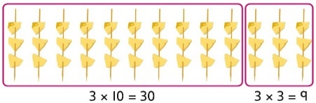  39 = 30 + 9  30 ÷ 3 = 10  9 ÷ 3 = 3  39 ÷ 3 = 13 | Partition into 100s, 10s and 1s using Base 10 equipment to divide where appropriate.  39 ÷ 3 = ?  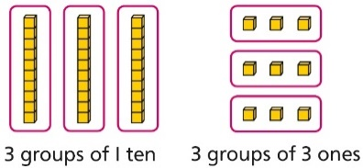  39 = 30 + 9  30 ÷ 3 = 10  9 ÷ 3 = 3  39 ÷ 3 = 13 | Partition into 100s, 10s and 1s using a part-whole model to divide where appropriate.  142 ÷ 2 = ?  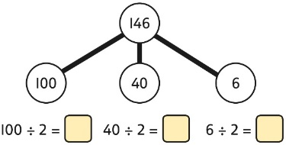  100 ÷ 2 = 50  40 ÷ 2 = 20  6 ÷ 2 = 3  50 + 20 + 3 = 73  142 ÷ 2 = 73
Dividing 2-digit and 3-digit numbers by a single digit, using flexible partitioning | Use place value equipment to explore why different partitions are needed.  42 ÷ 3 = ?  I will split it into 30 and 12, so that I can divide by 3 more easily.  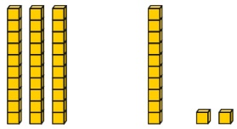 | Represent how to partition flexibly where needed.  84 ÷ 7 = ?  I will partition into 70 and 14 because I am dividing by 7.  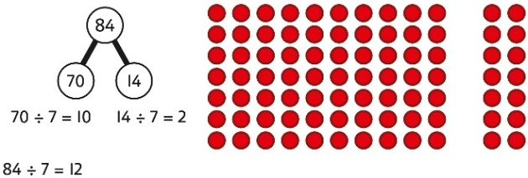 | Make decisions about appropriate partitioning based on the division required.  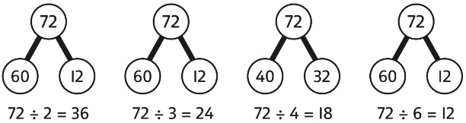  Understand that different partitions can be used to complete the same division.  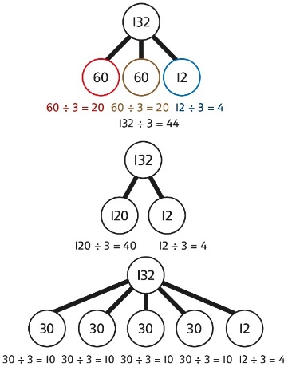
Understanding remainders | Use place value equipment to find remainders.  85 shared into 4 equal groups  There are 24, and 1 that cannot be shared.  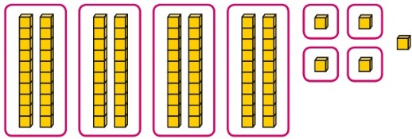 | Represent the remainder as the part that cannot be shared equally.  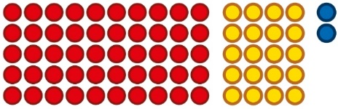  72 ÷ 5 = 14 remainder 2 | Understand how partitioning can reveal remainders of divisions.  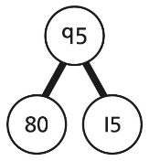  80 ÷ 4 = 20  12 ÷ 4 = 3  95 ÷ 4 = 23 remainder 3

UPPER KEY STAGE 2
In upper Key Stage 2, children build on secure foundations in calculation, and develop fluency, accuracy and flexibility in their approach to the four operations. They work with whole numbers and adapt their skills to work with decimals, and they continue to develop their ability to select appropriate, accurate and efficient operations.
Key language: decimal, column methods, exchange, partition, mental method, ten thousand, hundred thousand, million, factor, multiple, prime number, square number, cube number
Addition and subtraction: Children build on their column methods to add and subtract numbers with up to seven digits, and they adapt the methods to calculate efficiently and effectively with decimals, ensuring understanding of place value at every stage.  Children compare and contrast methods, and they select mental methods or jottings where appropriate and where these are more likely to be efficient or accurate when compared with formal column methods.  Bar models are used to represent the calculations required to solve problems and may indicate where efficient methods can be chosen. | Multiplication and division: Building on their understanding, children develop methods to multiply up to 4-digit numbers by single-digit and 2-digit numbers.  Children develop column methods with an understanding of place value, and they continue to use the key skill of unitising to multiply and divide by 10, 100 and 1,000.  Written division methods are introduced and adapted for division by single-digit and 2-digit numbers and are understood alongside the area model and place value. In Year 6, children develop a secure understanding of how division is related to fractions.  Multiplication and division of decimals are also introduced and refined in Year 6. | Fractions: Children find fractions of amounts, multiply a fraction by a whole number and by another fraction, divide a fraction by a whole number, and add and subtract fractions with different denominators. Children become more confident working with improper fractions and mixed numbers and can calculate with them.  Understanding of decimals with up to 3 decimal places is built through place value and as fractions, and children calculate with decimals in the context of measure as well as in pure arithmetic.  Children develop an understanding of percentages in relation to hundredths, and they understand how to work with common percentages: 50%, 25%, 10% and 1%.

Year 5
 | Concrete | Pictorial | Abstract
Year 5
Addition
Column addition with whole numbers | Use place value equipment to represent additions.  Add a row of counters onto the place value grid to show 15,735 + 4,012.  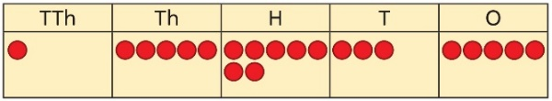 | Represent additions, using place value equipment on a place value grid alongside written methods.  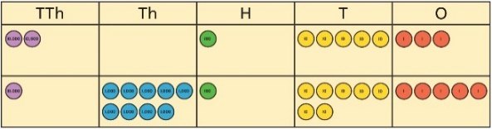  I need to exchange 10 tens for a 100.  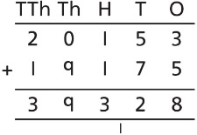 | Use column addition, including exchanges.  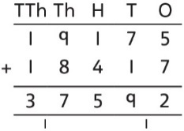
Representing additions |  | Bar models represent addition of two or more numbers in the context of problem solving.  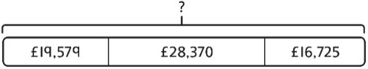  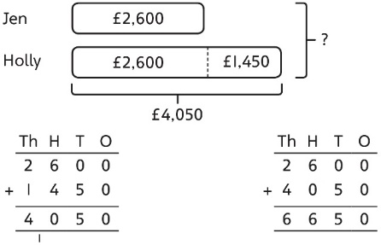 | Use approximation to check whether answers are reasonable.  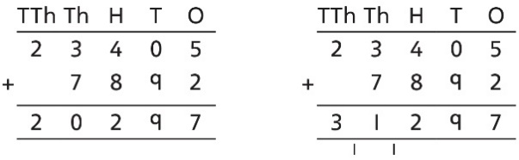  I will use 23,000 + 8,000 to check.
Adding tenths | Link measure with addition of decimals.  Two lengths of fencing are 0·6 m and  0·2 m.  How long are they when added together?  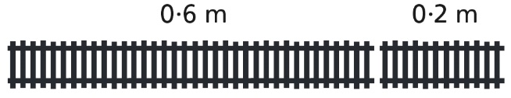 | Use a bar model with a number line to add tenths.  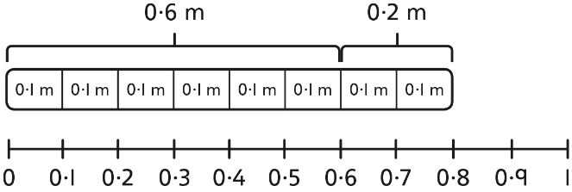  0·6 + 0·2 = 0·8  6 tenths + 2 tenths = 8 tenths | Understand the link with adding fractions.  $$\frac{6}{10}+\frac{2}{10}=\frac{8}{10}$$  6 tenths + 2 tenths = 8 tenths  0·6 + 0·2 = 0·8
Adding decimals using column addition | Use place value equipment to represent additions.  Show 0·23 + 0·45 using place value counters. | Use place value equipment on a place value grid to represent additions.  Represent exchange where necessary.  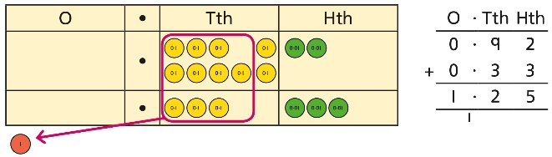  Include examples where the numbers of decimal places are different.  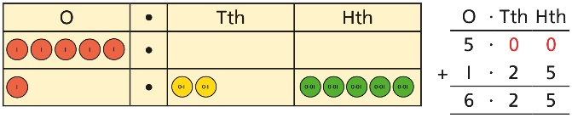 | Add using a column method, ensuring that children understand the link with place value.  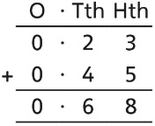  Include exchange where required, alongside an understanding of place value.  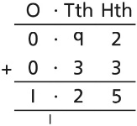  Include additions where the numbers of decimal places are different.  3.4 + 0.65 = ?  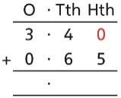
Year 5
Subtraction
Column subtraction with whole numbers | Use place value equipment to understand where exchanges are required.  2,250 – 1,070  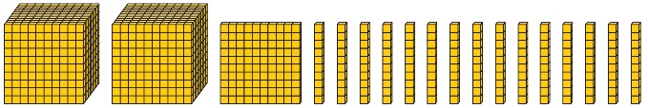 | Represent the stages of the calculation using place value equipment on a grid alongside the calculation, including exchanges where required.  15,735 − 2,582 = 13,153  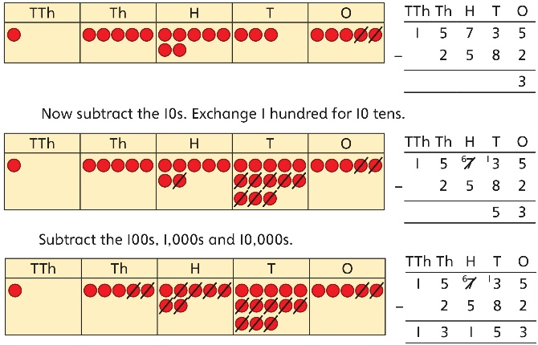 | Use column subtraction methods with exchange where required.  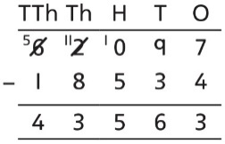  62,097 − 18,534 = 43,563
Checking strategies and representing subtractions |  | Bar models represent subtractions in problem contexts, including ‘find the difference’.  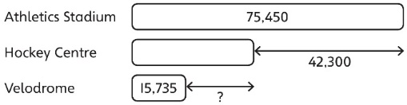 | Children can explain the mistake made when the columns have not been ordered correctly.  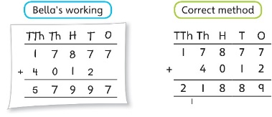  Use approximation to check calculations.  I calculated 18,000 + 4,000 mentally to check my subtraction.
Choosing efficient methods |  |  | To subtract two large numbers that are close, children find the difference by counting on.  2,002 − 1,995 = ?  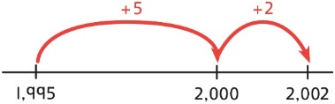  Use addition to check subtractions.  I calculated 7,546 − 2,355 = 5,191.  I will check using the inverse.
Subtracting decimals | Explore complements to a whole number by working in the context of length.  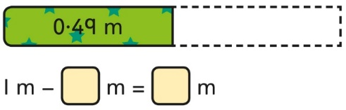  1 − 0·49 = ? | Use a place value grid to represent the stages of column subtraction, including exchanges where required.  5·74 − 2·25 = ?  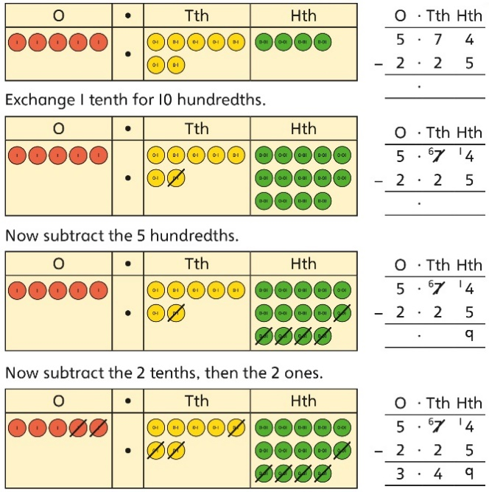 | Use column subtraction, with an understanding of place value, including subtracting numbers with different numbers of decimal places.  3·921 − 3·75 = ?  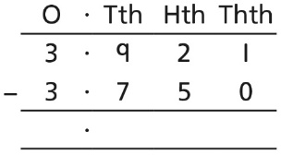
Year 5
Multiplication
Understanding factors | Use cubes or counters to explore the meaning of ‘square numbers’.  25 is a square number because it is made from 5 rows of 5.  Use cubes to explore cube numbers.  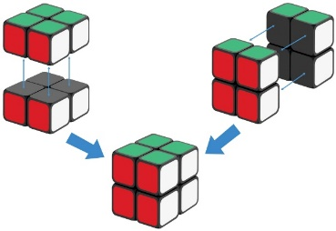  8 is a cube number. | Use images to explore examples and non-examples of square numbers.  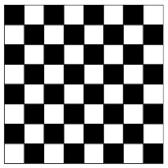  8 × 8 = 64  8² = 64  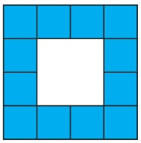  12 is not a square number, because you cannot multiply a whole number by itself to make 12. | Understand the pattern of square numbers in the multiplication tables.  Use a multiplication grid to circle each square number. Can children spot a pattern?
Multiplying by 10, 100 and 1,000 | Use place value equipment to multiply by 10, 100 and 1,000 by unitising.  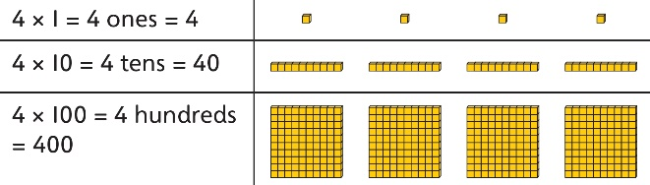 | Understand the effect of repeated multiplication by 10.  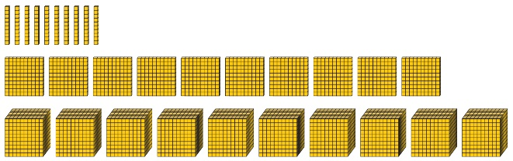 | Understand how exchange relates to the digits when multiplying by 10, 100 and 1,000.  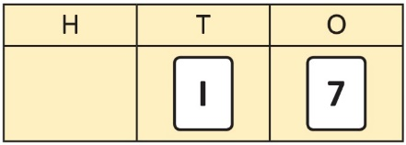  17 × 10 = 170  17 × 100 = 17 × 10 × 10 = 1,700  17 × 1,000 = 17 × 10 × 10 × 10 = 17,000
Multiplying by multiples of 10, 100 and 1,000 | Use place value equipment to explore multiplying by unitising.  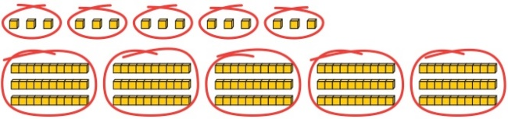  5 groups of 3 ones is 15 ones.  5 groups of 3 tens is 15 tens.  So, I know that 5 groups of 3 thousands would be 15 thousands. | Use place value equipment to represent how to multiply by multiples of 10, 100 and 1,000.  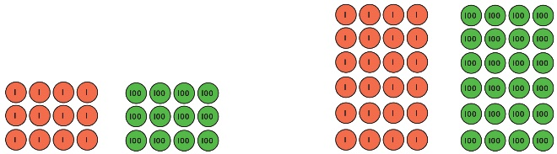  4 × 3 = 12 6 × 4 = 24  4 × 300 = 1,200 6 × 400 = 2,400 | Use known facts and unitising to multiply.  5 × 4 = 20  5 × 40 = 200  5 × 400 = 2,000  5 × 4,000 − 20,000  5,000 × 4 = 20,000
Multiplying up to 4-digit numbers by a single digit | Explore how to use partitioning to multiply efficiently.  8 × 17 = ?  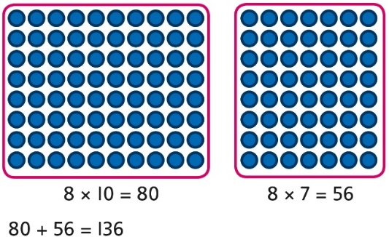  So, 8 × 17 = 136 | Represent multiplications using place value equipment and add the 1s, then 10s, then 100s, then 1,000s.  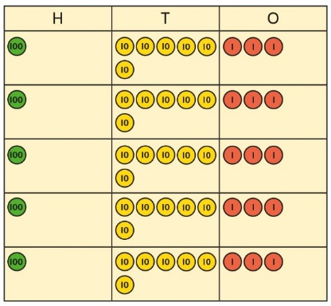 | Use an area model and then add the parts.  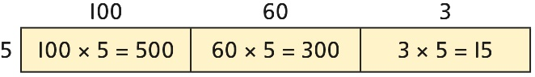  Use a column multiplication, including any required exchanges.  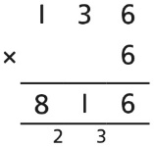
Multiplying 2-digit numbers by 2-digit numbers | Partition one number into 10s and 1s, then add the parts.  23 × 15 = ?  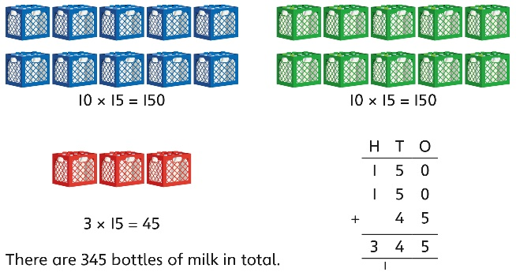  23 × 15 = 345 | Use an area model and add the parts.  28 × 15 = ?  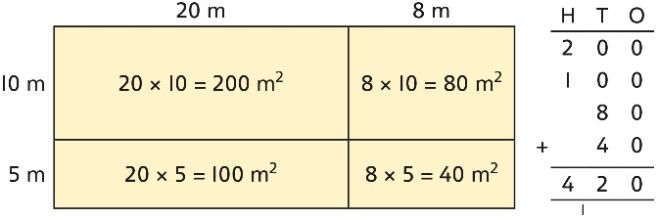  28 × 15 = 420 | Use column multiplication, ensuring understanding of place value at each stage.  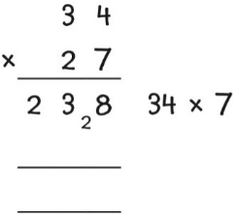  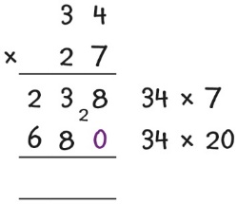  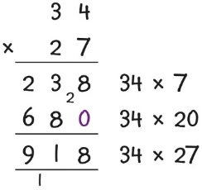
Multiplying up to 4-digits by 2-digits |  | Use the area model then add the parts.  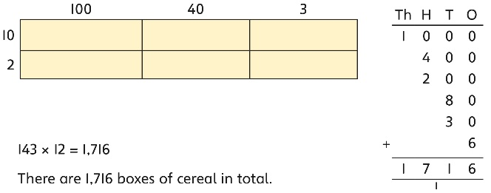  143 × 12 = 1,716 | Use column multiplication, ensuring understanding of place value at each stage.  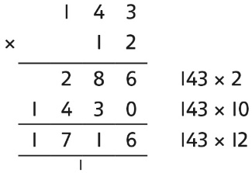  Progress to include examples that require multiple exchanges as understanding, confidence and fluency build.  1,274 × 32 = ?  First multiply 1,274 by 2.  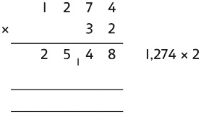  Then multiply 1,274 by 30.  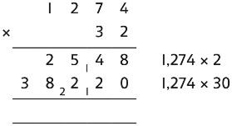  Finally, find the total.  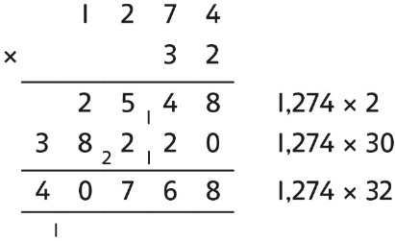  1,274 × 32 = 40,768
Multiplying decimals by 10, 100 and 1,000 | Use place value equipment to explore and understand the exchange of 10 tenths, 10 hundredths or 10 thousandths. | Represent multiplication by 10 as exchange on a place value grid.  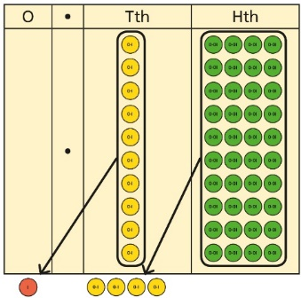  0·14 × 10 = 1·4 | Understand how this exchange is represented on a place value chart.  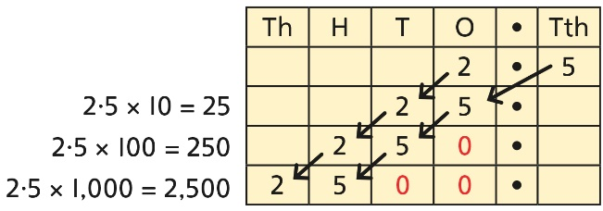
Year 5
Division
Understanding factors and prime numbers | Use equipment to explore the factors of a given number.    24 ÷ 3 = 8  24 ÷ 8 = 3  8 and 3 are factors of 24 because they divide 24 exactly.  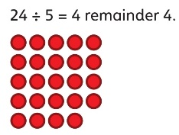  5 is not a factor of 24 because there is a remainder. | Understand that prime numbers are numbers with exactly two factors.  13 ÷ 1 = 13  13 ÷ 2 = 6 r 1  13 ÷ 4 = 4 r 1  1 and 13 are the only factors of 13.  13 is a prime number. | Understand how to recognise prime and composite numbers.  I know that 31 is a prime number because it can be divided by only 1 and itself without leaving a remainder.  I know that 33 is not a prime number as it can be divided by 1, 3, 11 and 33.  I know that 1 is not a prime number, as it has only 1 factor.
Understanding inverse operations and the link with multiplication, grouping and sharing | Use equipment to group and share and to explore the calculations that are present.  I have 28 counters.  I made 7 groups of 4. There are 28 in total.  I have 28 in total. I shared them equally into 7 groups. There are 4 in each group.  I have 28 in total. I made groups of 4. There are 7 equal groups. | Represent multiplicative relationships and explore the families of division facts.  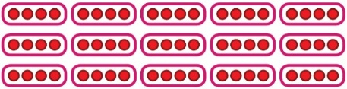  60 ÷ 4 = 15  60 ÷ 15 = 4 | Represent the different multiplicative relationships to solve problems requiring inverse operations.  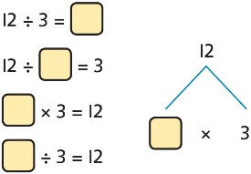  Understand missing number problems for division calculations and know how to solve them using inverse operations.  22 ÷ ? = 2  22 ÷ 2 = ?  ? ÷ 2 = 22  ? ÷ 22 = 2
Dividing whole numbers by 10, 100 and 1,000 | Use place value equipment to support unitising for division.  4,000 ÷ 1,000  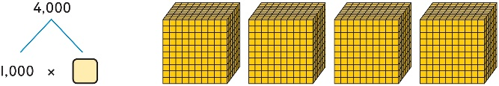  4,000 is 4 thousands.  4 × 1,000= 4,000  So, 4,000 ÷ 1,000 = 4 | Use a bar model to support dividing by unitising.  380 ÷ 10 = 38  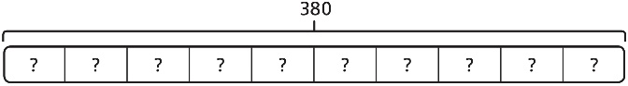  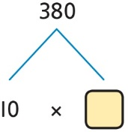  380 is 38 tens.  38 × 10 = 380  10 × 38 = 380  So, 380 ÷ 10 = 38 | Understand how and why the digits change on a place value grid when dividing by 10, 100 or 1,000.  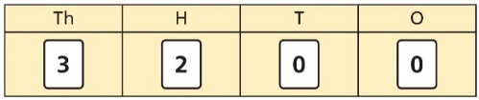  3,200 ÷ 100 = ?  3,200 is 3 thousands and 2 hundreds.  200 ÷ 100 = 2  3,000 ÷ 100 = 30  3,200 ÷ 100 = 32  So, the digits will move two places to the right.
Dividing by multiples of 10, 100 and 1,000 | Use place value equipment to represent known facts and unitising.  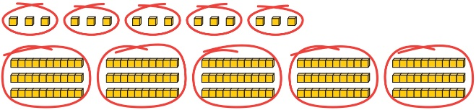  15 ones put into groups of 3 ones. There are 5 groups.  15 ÷ 3 = 5  15 tens put into groups of 3 tens. There are 5 groups.  150 ÷ 30 = 5 | Represent related facts with place value equipment when dividing by unitising.  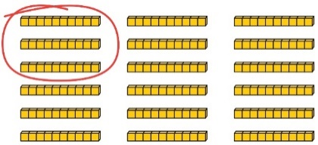  180 is 18 tens.  18 tens divided into groups of 3 tens. There are 6 groups.  180 ÷ 30 = 6  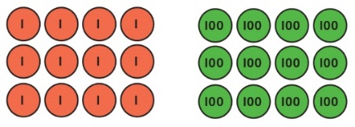  12 ones divided into groups of 4. There are 3 groups.  12 hundreds divided into groups of 4 hundreds. There are 3 groups.  1200 ÷ 400 = 3 | Reason from known facts, based on understanding of unitising. Use knowledge of the inverse relationship to check.  3,000 ÷ 5 = 600  3,000 ÷ 50 = 60  3,000 ÷ 500 = 6  5 × 600 = 3,000  50 × 60 = 3,000  500 × 6 = 3,000
Dividing up to four digits by a single digit using short division | Explore grouping using place value equipment.  268 ÷ 2 = ?  There is 1 group of 2 hundreds.  There are 3 groups of 2 tens.  There are 4 groups of 2 ones.  264 ÷ 2 = 134 | Use place value equipment on a place value grid alongside short division.  The model uses grouping.  A sharing model can also be used, although the model would need adapting.  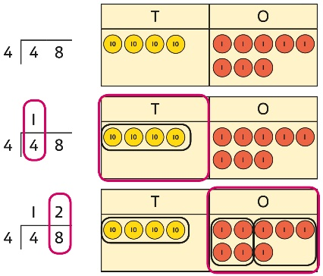  Lay out the problem as a short division.  There is 1 group of 4 in 4 tens.  There are 2 groups of 4 in 8 ones.  Work with divisions that require exchange.  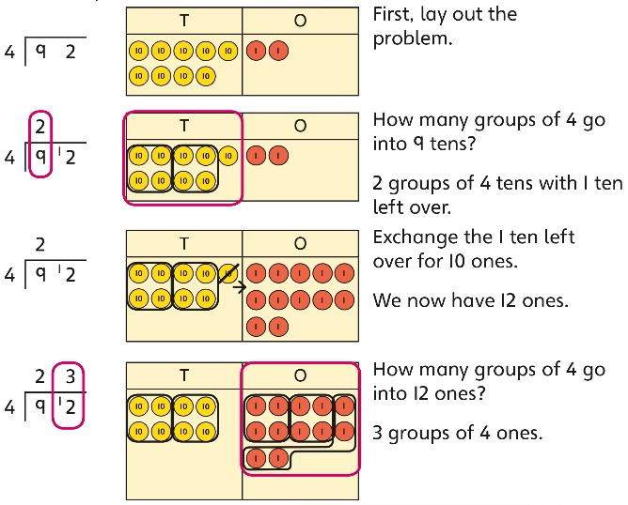 | Use short division for up to 4-digit numbers divided by a single digit.  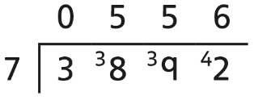  3,892 ÷ 7 = 556  Use multiplication to check.  556 × 7 = ?  6 × 7 = 42  50 × 7 = 350  500 × 7 = 3500  3,500 + 350 + 42 = 3,892
Understanding remainders | Understand remainders using concrete versions of a problem.  80 cakes divided into trays of 6.  80 cakes in total. They make 13 groups of 6, with 2 remaining. | Use short division and understand remainders as the last remaining 1s.  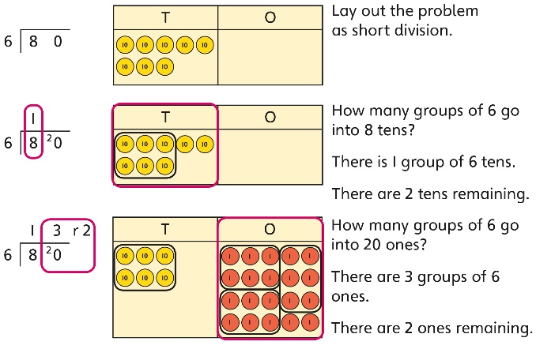 | In problem solving contexts, represent divisions including remainders with a bar model.  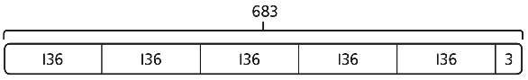  683 = 136 × 5 + 3  683 ÷ 5 = 136 r 3
Dividing decimals by 10, 100 and 1,000 | Understand division by 10 using exchange.  2 ones are 20 tenths.  20 tenths divided by 10 is 2 tenths. | Represent division using exchange on a place value grid.  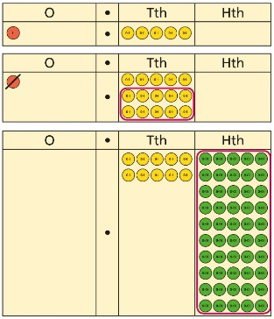  1·5 is 1 one and 5 tenths.  This is equivalent to 10 tenths and 50 hundredths.  10 tenths divided by 10 is 1 tenth.  50 hundredths divided by 10 is 5 hundredths.  1·5 divided by 10 is 1 tenth and 5 hundredths.  1·5 ÷ 10 = 0.15 | Understand the movement of digits on a place value grid.  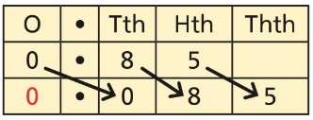  0·85 ÷ 10 = 0·085  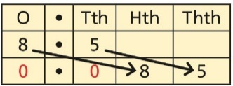  8·5 ÷ 100 = 0·085
Understanding the relationship between fractions and division | Use sharing to explore the link between fractions and division.  1 whole shared between 3 people.  Each person receives one-third.  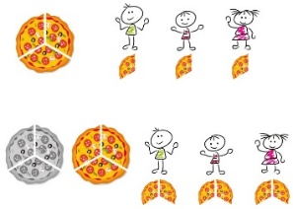 | Use a bar model and other fraction representations to show the link between fractions and division.  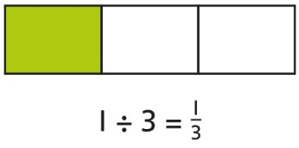 | Use the link between division and fractions to calculate divisions.  $$5÷4=\frac{5}{4}=1\frac{1}{4}$$  $$11 ÷4=\frac{11}{4}=2\frac{3}{4}$$
Year 6
 | Concrete | Pictorial | Abstract
Year 6
Addition
Comparing and selecting efficient methods | Represent 7-digit numbers on a place value grid, and use this to support thinking and mental methods.  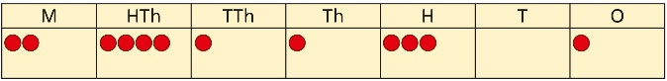 | Discuss similarities and differences between methods, and choose efficient methods based on the specific calculation.  Compare written and mental methods alongside place value representations.  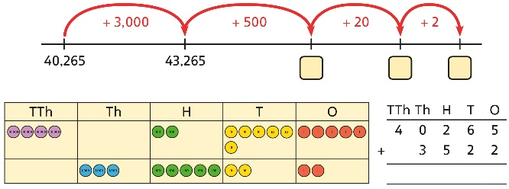  Use bar model and number line representations to model addition in problem-solving and measure contexts.  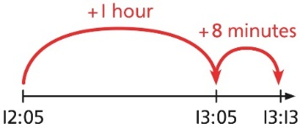 | Use column addition where mental methods are not efficient. Recognise common errors with column addition.  32,145 + 4,302 = ?  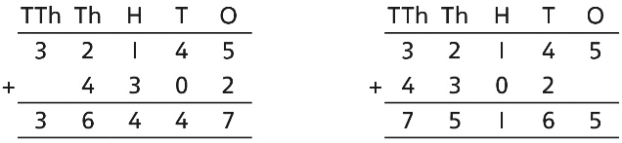  Which method has been completed accurately?  What mistake has been made?  Column methods are also used for decimal additions where mental methods are not efficient.  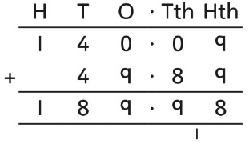
Selecting mental methods for larger numbers where appropriate | Represent 7-digit numbers on a place value grid, and use this to support thinking and mental methods.  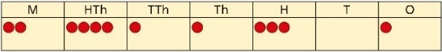  2,411,301 + 500,000 = ?  This would be 5 more counters in the HTh place.  So, the total is 2,911,301.  2,411,301 + 500,000 = 2,911,301 | Use a bar model to support thinking in addition problems.  257,000 + 99,000 = ?  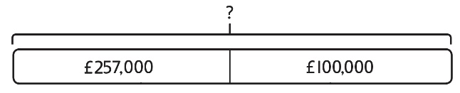  I added 100 thousands then subtracted  1 thousand.  257 thousands + 100 thousands = 357 thousands  257,000 + 100,000 = 357,000  357,000 – 1,000 = 356,000  So, 257,000 + 99,000 = 356,000 | Use place value and unitising to support mental calculations with larger numbers.  195,000 + 6,000 = ?  195 + 5 + 1 = 201  195 thousands + 6 thousands = 201 thousands  So, 195,000 + 6,000 = 201,000
Understanding order of operations in calculations | Use equipment to model different interpretations of a calculation with more than one operation. Explore different results.  3 × 5 − 2 = ?  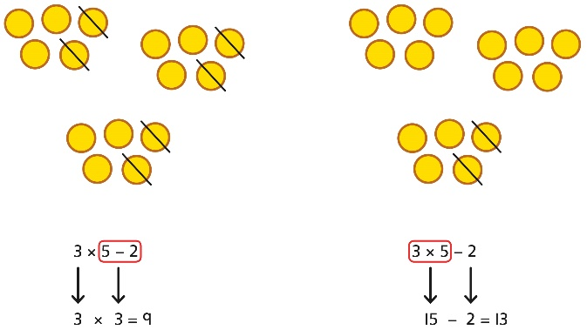 | Model calculations using a bar model to demonstrate the correct order of operations in multi-step calculations.  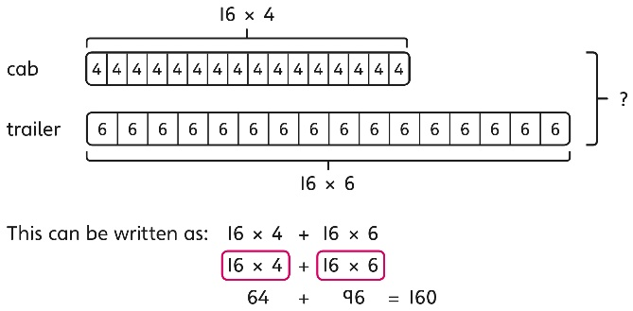 | Understand the correct order of operations in calculations without brackets.  Understand how brackets affect the order of operations in a calculation.  4 + 6 × 16  4 + 96 = 100  (4 + 6) × 16  10 × 16 = 160
Year 6
Subtraction
Comparing and selecting efficient methods | Use counters on a place value grid to represent subtractions of larger numbers.  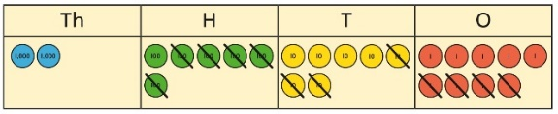 | Compare subtraction methods alongside place value representations.  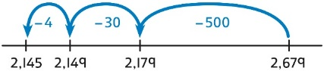  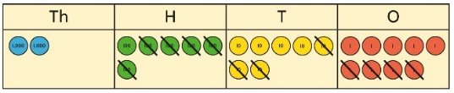  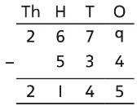  Use a bar model to represent calculations, including ‘find the difference’ with two bars as comparison.  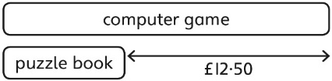 | Compare and select methods.  Use column subtraction when mental methods are not efficient.  Use two different methods for one calculation as a checking strategy.  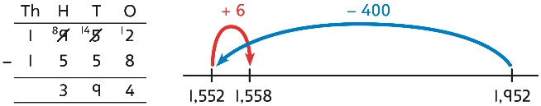  Use column subtraction for decimal problems, including in the context of measure.  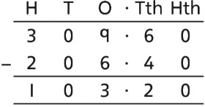
Subtracting mentally with larger numbers |  | Use a bar model to show how unitising can support mental calculations.  950,000 − 150,000  That is 950 thousands − 150 thousands  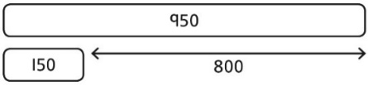  So, the difference is 800 thousands.  950,000 − 150,000 = 800,000 | Subtract efficiently from powers of 10.  10,000 − 500 = ?
Year 6
Multiplication
Multiplying up to a 4-digit number by a single digit number | Use equipment to explore multiplications.  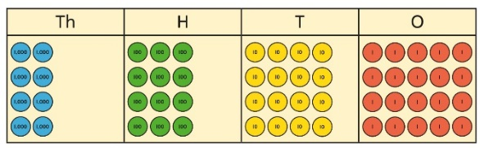  4 groups of 2,345  This is a multiplication:  4 × 2,345  2,345 × 4 | Use place value equipment to compare methods.  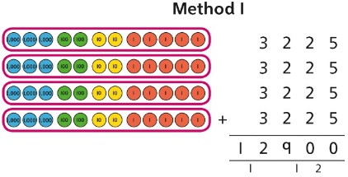  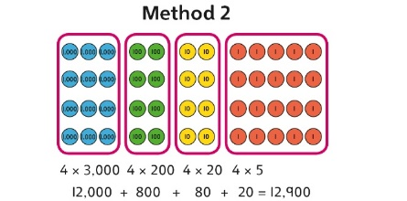 | Understand area model and short multiplication.  Compare and select appropriate methods for specific multiplications.  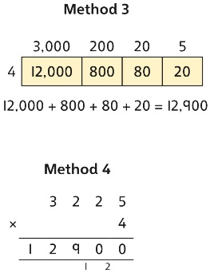
Multiplying up to a 4-digit number by a  2-digit number |  | Use an area model alongside written multiplication.  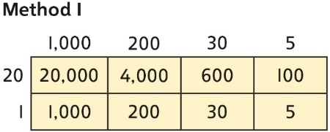  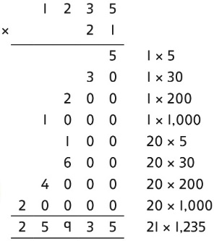 | Use compact column multiplication with understanding of place value at all stages.  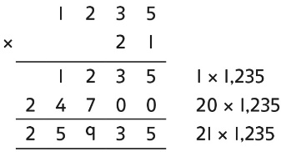
Using knowledge of factors and partitions to compare methods for multiplications | Use equipment to understand square numbers and cube numbers.  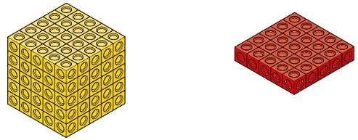  5 × 5 = 5² = 25  5 × 5 × 5 = 5³ = 25 × 5 = 125 | Compare methods visually using an area model. Understand that multiple approaches will produce the same answer if completed accurately.  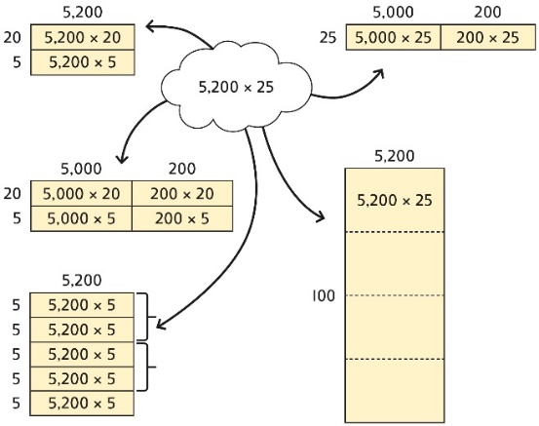  Represent and compare methods using a bar model. | Use a known fact to generate families of related facts.  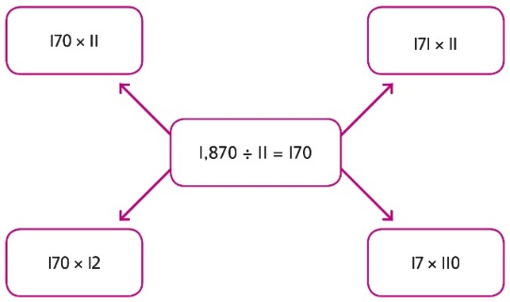  Use factors to calculate efficiently.  15 × 16  = 3 × 5 × 2 × 8  = 3 × 8 × 2 × 5  = 24 × 10  = 240
Multiplying by 10, 100 and 1,000 | Use place value equipment to explore exchange in decimal multiplication.  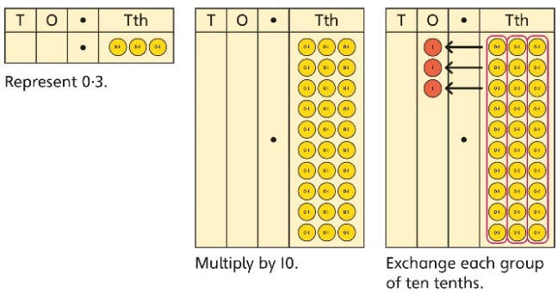  0·3 × 10 = ?  0·3 is 3 tenths.  10 × 3 tenths are 30 tenths.  30 tenths are equivalent to 3 ones. | Understand how the exchange affects decimal numbers on a place value grid.  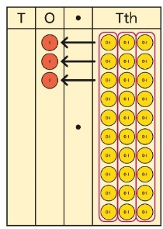  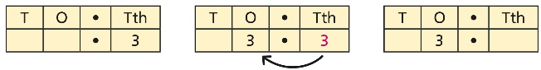  0·3 × 10 = 3 | Use knowledge of multiplying by 10, 100 and 1,000 to multiply by multiples of 10, 100 and 1,000.  8 × 100 = 800  8 × 300 = 800 × 3  = 2,400  2·5 × 10 = 25  2·5 × 20 = 2·5 × 10 × 2  = 50
Multiplying decimals | Explore decimal multiplications using place value equipment and in the context of measures.  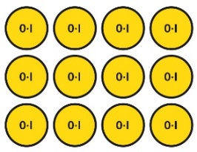  3 groups of 4 tenths is 12 tenths.  4 groups of 3 tenths is 12 tenths.  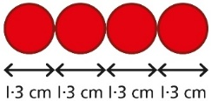  4 × 1 cm = 4 cm  4 × 0·3 cm = 1.2 cm  4 × 1·3 = 4 + 1·2 = 5·2 cm | Represent calculations on a place value grid.  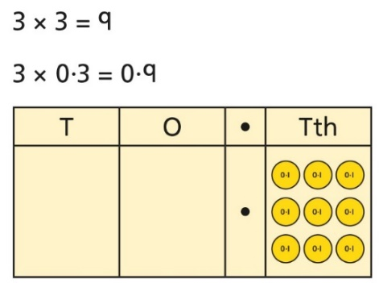  Understand the link between multiplying decimals and repeated addition.  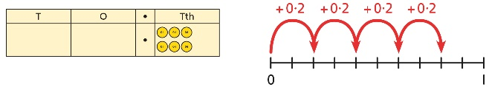 | Use known facts to multiply decimals.  4 × 3 = 12  4 × 0·3 = 1·2  4 × 0·03 = 0·12  20 × 5 = 100  20 × 0·5 = 10  20 × 0·05 = 1  Find families of facts from a known multiplication.  I know that 18 × 4 = 72.  This can help me work out:  1·8 × 4 = ?  18 × 0·4 = ?  180 × 0·4 = ?  18 × 0·04 = ?  Use a place value grid to understand the effects of multiplying decimals.  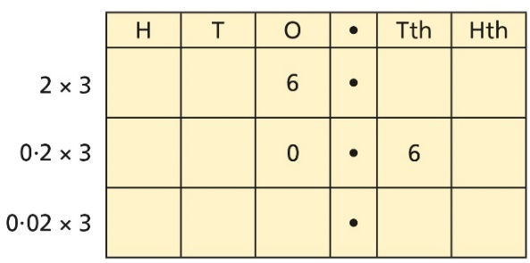
Year 6
Division
Understanding factors | Use equipment to explore different factors of a number.  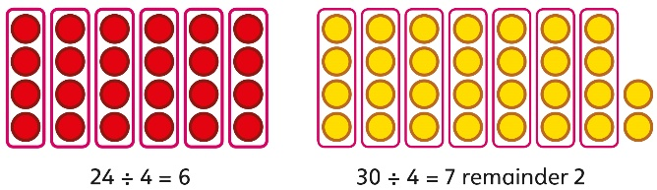  4 is a factor of 24 but is not a factor of 30. | Recognise prime numbers as numbers having exactly two factors. Understand the link with division and remainders.  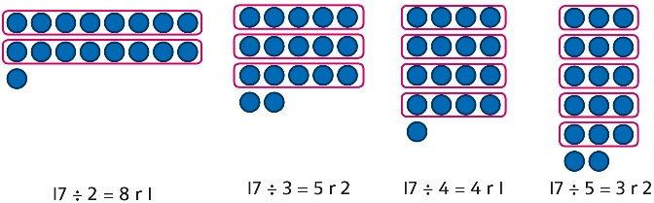 | Recognise and know primes up to 100.  Understand that 2 is the only even prime, and that 1 is not a prime number.  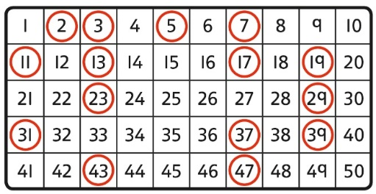
Dividing by a single digit | Use equipment to make groups from a total.  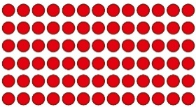  There are 78 in total.  There are 6 groups of 13.  There are 13 groups of 6. | 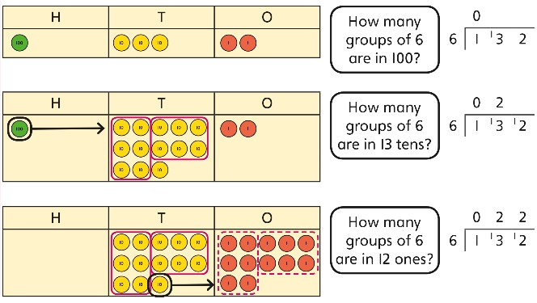 | Use short division to divide by a single digit.  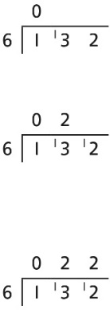  Use an area model to link multiplication and division.  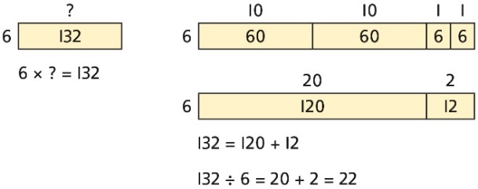
Dividing by a 2-digit number using factors | Understand that division by factors can be used when dividing by a number that is not prime. | Use factors and repeated division.  1,260 ÷ 14 = ?  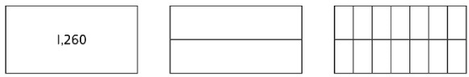  1,260 ÷ 2 = 630  630 ÷ 7 = 90  1,260 ÷ 14 = 90 | Use factors and repeated division where appropriate.  2,100 ÷ 12 = ?  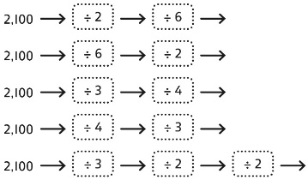
Dividing by a 2-digit number using long division | Use equipment to build numbers from groups.  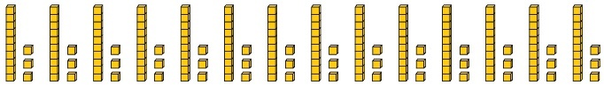  182 divided into groups of 13.  There are 14 groups. | Use an area model alongside written division to model the process.  377 ÷ 13 = ?  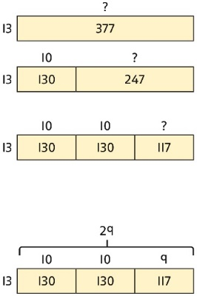  377 ÷ 13 = 29 | Use long division where factors are not useful (for example, when dividing by a  2-digit prime number).  Write the required multiples to support the division process.  377 ÷ 13 = ?  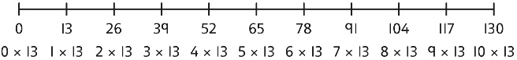  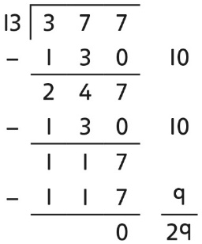  377 ÷ 13 = 29  A slightly different layout may be used, with the division completed above rather than at the side.  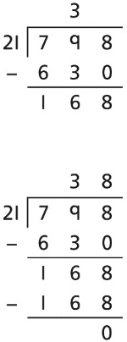  Divisions with a remainder explored in problem-solving contexts.
Dividing by 10, 100 and 1,000 | Use place value equipment to explore division as exchange.  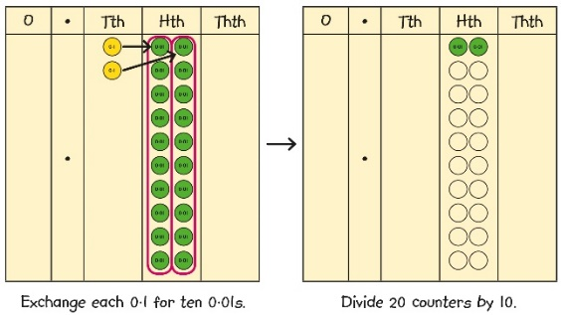  0·2 is 2 tenths.  2 tenths is equivalent to 20 hundredths.  20 hundredths divided by 10 is 2 hundredths. | Represent division to show the relationship with multiplication. Understand the effect of dividing by 10, 100 and 1,000 on the digits on a place value grid.  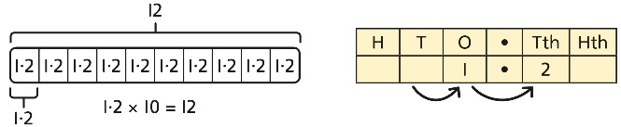  Understand how to divide using division by 10, 100 and 1,000.  12 ÷ 20 = ?  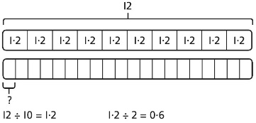 | Use knowledge of factors to divide by multiples of 10, 100 and 1,000.  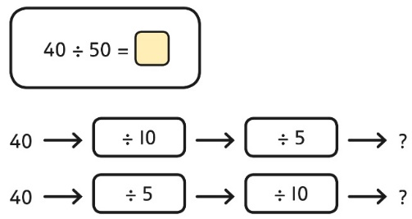  40 ÷ 5 = 8  8 ÷ 10 = 0·8  So, 40 ÷ 50 = 0·8
Dividing decimals | Use place value equipment to explore division of decimals.  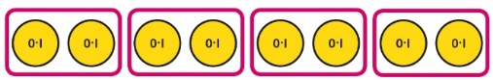  8 tenths divided into 4 groups. 2 tenths in each group. | Use a bar model to represent divisions.  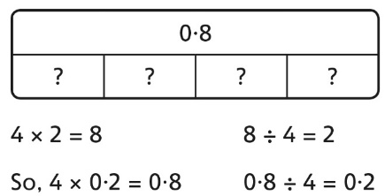 | Use short division to divide decimals with up to 2 decimal places.  

