

Water Primary School

Art and Design Policy

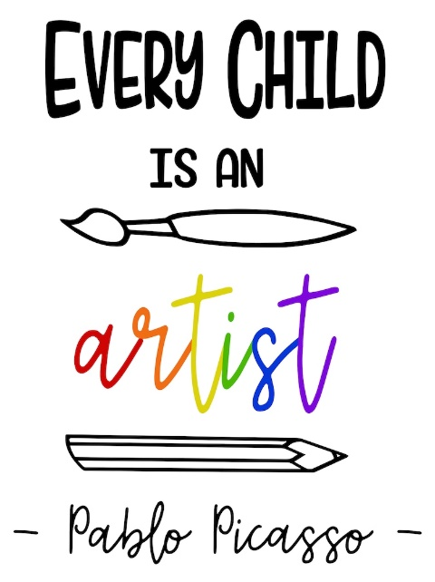

Member of staff responsible: Emma Smith
Policy reviewed: September 2025
Date to be reviewed: September 2026

MISSION STATEMENT
At Water Primary, we work in partnership with parents and the community to achieve the highest standards. Our main goal is to encourage our children to be resilient, respectful and independent learners, who are equipped for lifelong learning. Through stimulating, safe learning environments and excellent opportunities to succeed in and out of the classroom, we encourage children’s progress and achievements. At Water, we welcome the importance Art and Design has in our curriculum to develop pupils creative and imaginative skills. We will promote these skills through exploring a range of artistic styles as well as studying different artists.

AIMS
At Water School we aim to deliver quality art and design education which engages, inspires and challenges pupils, equipping them with the knowledge and skills to experiment, invent and create their own works of art, craft and design. Our aim is to inspire, motivate and nurture the next generation of creative and critical thinkers. We hope to develop the children’s confidence to experiment and invent their own works of art.
We aim to develop each child’s individual abilities, nurture their talents and interest and allow them to express their ideas and thoughts about the world around them.

CURRICULUM AND SCHOOL ORGANISATION
In order to achieve these aims, art and design is planned using the Kapow schemes of work. Our objectives are derived from the national curriculum and we ensure that art and design is taught every half term.
Each year group learns skills in;
Drawing
Painting and Mixed Media
Sculpture and 3D
Craft and Design
These themes are carefully planned on a rolling curriculum to suit our mixed age classes.
We offer children the opportunity to work individually or in groups in a balanced programme of art, craft and design. The children are encouraged to further their abilities through practice as well as using art in cross curricular activities and using their sketchbooks. The EYFS setting will follow the Statutory Framework for the EYFS (2021) to ensure a breadth of experiences are taking place which are linked to art.
The National Curriculum (2014) aims to ensure that all pupils:
- produce creative work, exploring their ideas and recording their experiences
- become proficient in drawing, painting, sculpture and other art, craft and design techniques
- evaluate and analyse creative works using the language of art, craft and design
- know about great artists, craft makers and designers, and understand the historical and cultural development of their art forms
We always begin a unit with a hook lesson, where children are introduced to artists who have produced work linking with the half term theme. They are encouraged to appreciate the art, select favourite pieces and be inspired to create works of their own.

PLANNING AND DELIVERY
Planning is used to:
- set clear and achievable goals;
- ensure work is matched to pupils’ abilities, experience and interests;
- ensure progression, continuity and subject coverage throughout the School.
- set high expectations and provide opportunities for all pupils to achieve regardless of race, gender or disability.
- Plan future teaching and learning.
- Provide summative information for parents and teachers. A range of assessment techniques is used including:
- Teacher observation of children working.
- Discussion with and questioning of pupils.
- Marking and evaluation of any written work.
- Taking pictures of the process and final piece of art on displays.
- Evaluation of completed work – by the children as well as the teacher.
- Using the national curriculum objectives to assess against.
- Set suitable learning challenges.
- Respond to pupils' diverse learning needs.
- Overcome potential barriers to learning and assessment for individuals and groups of pupils.

We will use the Kapow Art and Design Scheme of Work to support our implementation. This scheme us designed with four strands that run throughout. These are:
  - Making skills
  - Formal elements (line, shape, tone, texture, pattern and colour)
  - Knowledge of artists
  - Evaluating
Through this scheme of work, these strands are revisited in every unit. Pupils have the opportunity to learn and practice skills discreetly. Key skills are revisited again and again with increasing complexity in a spiral curriculum model. This allows pupils to revise and build on their previous learning.

ICT
Pupils will be given opportunities to use ICT to aid their art learning including using programmes such as Purple Mash and also the internet to look at a range of artists and techniques. When using ICT, our ICT policy will be followed.

ASSESSMENT, RECORD KEEPING AND RECORDING
We assess the children by completing learning journeys at the beginning of each unit of work. Objectives and steps to success are carefully planned and these are used to effectively assess each child after each session. Assessment is the responsibility of the class teacher and is used to:
- Plan future teaching and learning.
- Provide summative information for parents and teachers. A range of assessment techniques is used including:
- Teacher observation of children working.
- Discussion with and questioning of pupils.
- Marking and evaluation of any artwork.
- Taking pictures of the process and the final piece of work.
- Evaluation of completed work – by the children as well as the teacher.
- Using national curriculum objectives and assess pupils against these.
The children are involved in the evaluation, dialogue and decision making about the quality of their outcomes and the improvements they need to make. By taking part in regular discussions and decision- making processes, children will not only know facts and key information about art, but they will be able to talk confidently about their own learning journey, have higher metacognitive skills and have a growing understanding of how to improve.
The impact of our art and design curriculum can be constantly monitored through both formative and summative assessment opportunities. Each lesson will assess pupils against the learning objectives abd steps to success.

EQUAL OPPORTUNITIES
It is the responsibility of all teachers to ensure that all pupils, irrespective of gender, ability, race and social circumstance, have access to the art and design curriculum and make the greatest progress possible.

SPECIAL EDUCATIONAL NEEDS/INCLUSION
The school will work to ensure that all pupils including those with special educational needs are provided with an appropriate art and design curriculum. See the SEND adaptations document for more details.

AGT
Able, Gifted and Talented children should be identified and noted on the school AGT register. Appropriate opportunities should be provided for them to share and develop their talents. The teacher should ensure that children are suitably challenged and extended within the lessons.

RESOURCES
Resources are stored in the Art cupboards (Kitchen area) and paper can be taken from the paper cupboard by the school offices. It is the teacher’s responsibility to look after the resources and the coordinators role to replenish the products.

INTENT
By using the Kapow scheme of work, Waterv Primary aims to nurture pupils’ creativity, imagination and visual literacy, encouraging them to think like artists and designers. The intention is for pupils to develop the confidence to experiment, express ideas and communicate meaning through visual and tactile media. By using Kapow, we intend to promote an appreciation of art as a powerful form of human expression, helping pupils to understand its role across different cultures, time periods and creative industries. We encourage children to value originality, take creative risks and reflect critically on their own work and that of others. By using the Kapow sheme of work, we intend that teachers develop their subject knowledge and pedagogical confidence, enabling the delivery of rich, engaging and purposeful lessons. The curriculum is designed to be both inclusive and ambitious, ensuring all pupils are equipped to enjoy, create and respond to art in meaningful ways.
IMPLEMENTATION
At Water Primary we follow the Kapow Scheme of work. We ensure a broad and balanced Art and Design curriculum that builds on previous learning and provides both support and challenge for learners. We follow a scheme that ensures progression of skills and covers all aspects of the Design and Technology curriculum.
Children’s work and pictures of their work will be stored on the teachers drive and shared on the ‘Water Curriculum’ section of the website for reference and assessment. At Water Primary, we teach Art and Design each week, alternating every half term with Design and technology. We want to ensure that Art and Design is embedded in our whole school curriculum and that opportunities for enhancing learning by using Art and Design are always taken.

IMPACT
Children who follow our art and design scheme of work will;
  - Produce creative work, exploring and recording their ideas and experiences.
  - Be proficient in drawing, painting, sculpture and other art, craft and design techniques.
  - Evaluate and analyse creative works using subject-specific language.
  - Know about great artists and the historic and cultural development of their art.
  - Meet the end of key stage expectations outlined in the EYFS (Expressive arts and design) and National curriculum for art and design.

