Water Primary School
Religious Education Policy
2025/2026


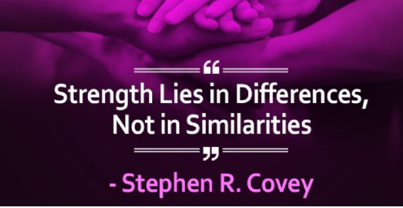

The context of RE
At Water Primary School Religious Education is taught in accordance with the Lancashire Locally Agreed Syllabus. This is an ambitious curriculum and outlines the curriculum intent and methods of implementation that will enable all pupils to achieve well and attain high level outcomes by the end of each key stage.

The syllabus aims to support pupil's personal search for meaning as they explore what it means to be human. It follows the Lancashire mixed-age medium term planning model, but also specifies knowledge and skills which build towards clear goals at the end of each key stage. This ensures that the curriculum is progressive, clearly sequenced and suitably ambitious. It is rooted in disciplinary knowledge based in theology, social sciences and philosophy.
We recognise the variety of religious and non-religious backgrounds from which our pupils come. The taught syllabus is not designed to convert pupils, or to promote a particular religion or religious belief. As a school we maintain that teaching about religions and worldviews should be sufficiently fair, balanced and open. We aim to promote mutual respect and understanding, whilst not undermining or ignoring the role of families and religious or belief organisations in transmitting values to successive generations.

Legal requirements
RE at Water Primary will meet legal requirements by:
- Its inclusion in the curriculum of all registered pupils. In primary schools, this is a requirement for all pupils in Reception to Year 6.
- Reflecting the fact that religious traditions in Greater Britain are the main Christian, while taking account of the teaching and practices of the other principal religious traditions represented in Great Britain.
- Teaching RE in accordance with Lancashire Locally Agreed Syllabus.
Purpose and Aims of Religious Education
At Water we believe that studying religious and non-religious worldviews is essential if pupils are to be well prepared for life in our increasingly diverse society. Pupils need to acquire the necessary knowledge and skills to make sense of the complex world in which they live so that they can 'respect religious and cultural differences and contribute to a cohesive and compassionate society' (RE Review 2013).
Religious Education provokes challenging questions about the ultimate meaning and purpose of life, beliefs about God, the self and the nature of reality, issues of right and wrong, and what it means to be human.
Pupils learn to weigh up the value of wisdom from different sources, to develop and express insights in response, and to agree or disagree respectfully.
Pupils are encouraged to articulate clearly and coherently their personal beliefs, ideas, values and experiences so that they can hold balanced and well-informed conversations about religions and worldviews whilst respecting the views of others.
Our curriculum for Religious Education aims to ensure that all pupils:
- Know about and understand a range of religions and worldviews, so that they can:
- describe, explain and analyse beliefs and practices, recognising the diversity which exists within and between communities and amongst individuals;
- identify, investigate and respond to questions posed, and responses offered by some of the sources of wisdom found in religions and worldviews; and
- appreciate and evaluate the nature, significance and impact of different ways of life and ways of expressing meaning
- Express ideas and insights about the nature, significance and impact of religions and worldviews, so that they can:
- explain reasonably their ideas about how beliefs, practices and forms of expression influence individuals and communities;
- express with increasing discernment their personal reflections and critical responses to questions and teachings about identity, diversity, meaning and value, including ethical issues; and
- appreciate and appraise varied dimensions of religion or a worldview
- Gain and deploy the skills needed to engage seriously with religions and worldviews, so that they can:
- find out about and investigate key concepts and questions of belonging, meaning, purpose and truth, responding creatively;
- enquire into what enables different individuals and communities to live together respectfully for the wellbeing of all; and
- articulate beliefs, values and commitments clearly in order to explain why they may be important in their own and other people’s lives.
('A Curriculum Framework for Religious Education in England' Religious Education Council October 2013)
Curriculum Structure
Planning
We plan from the Lancashire Agreed Syllabus for RE 2021. In KS1 and KS2, pupils must have opportunities to learn about Christianity and at least two other principle religions, and other religions and beliefs represented in the school community. In KS2, this will extend to religions and beliefs beyond the local area – the Lancashire region and recognising the impact of religion and belief locally, nationally and globally. Each key stage will follow a rolling program of enquiry-based study over two years for KS1 and 4 years for KS2, based on the following questions:

KS1:
What do people say about God?
How do we respond to things that really matter?

KS2:
Who should we follow?
How should we live our lives?
Where can people find guidance about how to live our lives?
In what ways is life like a journey?
One hour per week, should be devoted to RE, excluding assemblies.

See Appendix 1 for long term planning.

EYFS
Religious Education and the Early Years Foundation Stage Religious Education is a statutory requirement for all pupils registered on the school roll, including those children in EYFS in reception classes. The promotion of equality, diversity and British values should be at the heart of all early years’ settings and as such will form a distinct area of enquiry as part of any Ofsted inspection. In reception classes the beginnings in Religious Education can be taught through the Statutory Early Years Framework through the strand ‘People and Communities’ within the area of development entitled ‘Understanding the World’ (EYFS Statutory Framework 2021).
The knowledge, skills and understanding that should be acquired by the end of the reception year is as follows: Know some similarities and differences between different religious and cultural communities in this country, drawing on their experiences and what has been read in class.
Religious Education can also make an active contribution and support development within other areas of learning and development, in particular:
• Communication and Language (Listening and Speaking).
• Literacy (Comprehension, Word Reading and Writing).
• Personal, Social and Emotional Development (self-regulation, managing self and building relationships).
• Expressive Arts and Design (creating with materials and performing).
• Understanding the World (past and present, the natural world).
Effective Early Years practice applies and in reception classes Religious Education should be taught through a mix of adult led, child initiated and guided activity. Skills should be carefully modelled during whole class or group teaching and wherever possible within enhanced areas of provision. At this early stage children should be encouraged to follow lines of enquiry, ask and answer questions and discuss and express their ideas. Opportunities to create a calm and reflective space to enable children to consider, discuss and express their ideas should be promoted.
Encounters with other religions should be primarily promoted via stories, rhymes, songs and artefacts with specialist vocabulary taught alongside. A multi-sensory, play based approach should be promoted. Teachers should enable children to develop characteristics of effective learning by providing opportunities to:
• Investigate and experience new things
• Play and explore
• ‘Have a go’: concentrating, persevering, developing strategies
• Develop own ideas, problem solve and follow lines of enquiry
Strategies for the teaching of Religious Education
A variety of strategies will be used for the teaching of Religious Education. Work will seek to promote open enquiry and respect. The variety of strategies will include:
• Individual work
• Group work (groups can be mixed ability with differentiation by role or ability groups with differentiation by outcome).
• Class work
• The use of ICT to develop, support and enhance learning where appropriate.
• Visitors into school
RE is taught at a level appropriate to age, ability and experience; and is accessible to every child through personalised learning, differentiation of work and support.
EAL Children with EAL will have full access to RE, with support from the EAL team if needed.
Gifted and Talented
These children are identified in planning and provided with appropriate challenges.
Resources
Resources are located in the labelled ‘RE’ cupboard or in Hazel class. Teachers make good use of resources in order to ensure that RE lessons are inspiring for pupils and effectively promote progress.
Equal Opportunities
Religious Education is taught in accordance with our school's Equality Opportunity Policy. Stereotypes are avoided. Attempts are made to ensure that examples of religious figures reflect all aspects of diversity within society.

Pupils will develop a sense of citizenship through many aspects of the explicit RE curriculum. Links will be made with people and communities within the locality.

The RE curriculum makes a significant contribution to pupils’ spiritual, moral, social and cultural (SMSC) development and awareness of Prevent and British values.

Links with other subjects
Although Religious Education is taught as a separate subject discipline, opportunities arise in lessons for children to apply skills from other subject areas. For example, in English, art, drama, computing, technology. This ensures that the curriculum is taught in a creative and engaging manner as well as being knowledge rich and ambitious.

Monitoring & Evaluation
Standard self-evaluation procedures are used to monitor and evaluate pupil achievement, the quality of teaching and the effectiveness of curriculum provision in Religious Education.
The subject leader will maintain a clear overview of the intent, implementation and impact of Religious Education through planned monitoring tasks included with the school's overall monitoring schedule. This might involve reporting to SLT and Governors to support their evaluation and contributing to the school's 'self-evaluation' in preparation for the next Ofsted inspection.
It is the statutory duty of the governing body to ensure that:
- Religious Education is included in the basic curriculum and that the school meets its statutory duties.
- Sufficient time and resources are devoted to Religious Education to provide a curriculum of quality.
Withdrawal
We note the Human Right of parents to withdraw their children from Religious Education and of teachers to withdraw from teaching the subject. We aim to provide an open curriculum which can be taught to all pupils, by all staff.
Teachers are asked to refer to the head teacher any questions from parents about withdrawals. Requests for full or partial withdrawal from RE should be made in writing to the head teacher and a record kept of them.
If you need any further information about withdrawal please contact school.

Assessment

Assessment Teachers are required to assess pupils each term. The age-related skills for each year group are outlined on trackers and teachers identify where each of their pupils are working - ‘Below’, ‘Entering’, ‘Developing’ or ‘Secure’. The summer term assessments for Year 2 and Year 6 are reported on and will be sent to Lancashire SACRE (The Standing Advisory Council on Religious Education).

Visitors and visits to places of worship
We enrich the curriculum by organising visits to places of worship in the immediate vicinity of the school. Faith leaders and other members of the community are also invited when appropriate to contribute to learning in the classroom as an additional valued resource.
Guidance on visits and visitors can be found in the school's visitor policy.
The RE subject leader supports class teachers to organise these educational visits.

Named RE subject leader: Chloe Ashworth
Headteacher: Elizabeth Mckay
Date: 07.10.2025
Date for review: October 2026

Appendix 1
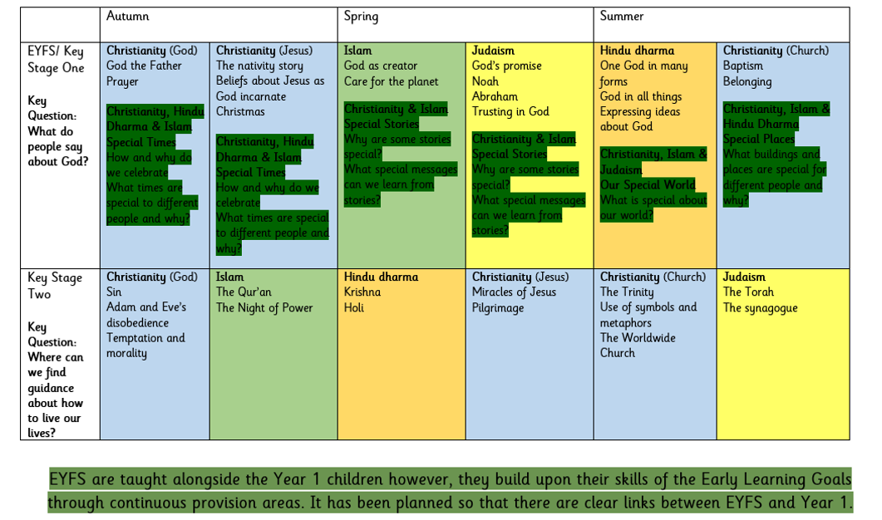
2024/2025

